**Capstone Project: Create a Testing Framework for Sporty Shoes Website**

**Project objective:**

The objective is to develop a comprehensive QA and test suite for the Sporty Shoes website. The QA effort will require the following:

1. Browser-based end-user testing using Selenium WebDriver with TestNG Framework.
2. Load Testing using JMeter.
3. API Testing with Cucumber.
4. API Testing with Postman and Rest Assured.

The end deliverables will be executable scripts and modules that can be run on demand for testing the Sporty Shoes web app.

**Background of the problem statement:**

Sporty Shoes has an e-commerce website that has the following existing features in place:

* Users can view products.
* If users want to purchase something, they can first sign up and then log in.
* Users can add multiple items to their cart and do a checkout.
* Users have a dashboard that lets them edit their profile, view past purchases, and view their cart.
* Once users do a checkout, the items are cleared from their cart and an order is generated which is stored in their order history.

The above application is already functional. What is needed now is to add a testing layer that will ensure that everything is passed through QA.

🡺WriteUp:

The following deliverables are expected:

1. Automate the below API endpoints using Rest-Assured

* Retrieve the list of all products in the store.
* Retrieve the list of all registered users.
* Add the product.
* Delete the product.
* Update the product.

🡺Source Code:

=>Retrieve the list of all products in the store.

**package** com.sporty.shoes.restAssuredScript;

**import** org.testng.Assert;

**import** org.testng.annotations.Test;

**import** io.restassured.response.Response;

**import** io.restassured.RestAssured;

**public** **class** GetAllShoes {

@Test (priority='1')

**public** **void** get_all_shoes()

{

Response response =RestAssured.*given*()

.baseUri("http://localhost:9010")

.basePath("/get-shoes")

.when()

.get()

.then()

.statusCode(200)

.extract()

.response();

System.***out***.println(response.getBody().asPrettyString());

System.***out***.println("Status Code " + response.getStatusCode());

System.***out***.println("Response Time: "+response.getTime());

**int** expectStatusCode = 200;

**int** ActualStatusCode = response.getStatusCode();

Assert.*assertEquals*(expectStatusCode, ActualStatusCode);

}

}

🡺ScreenShot:

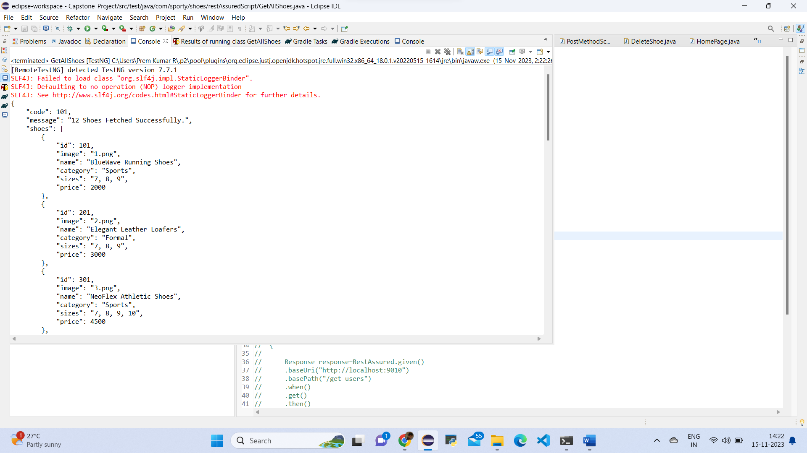

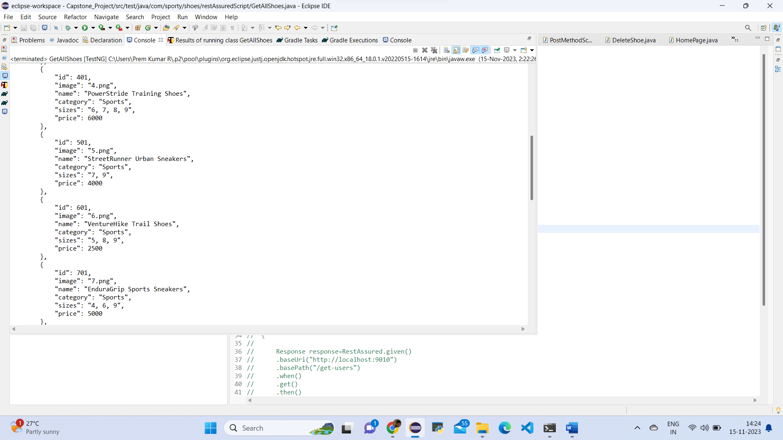

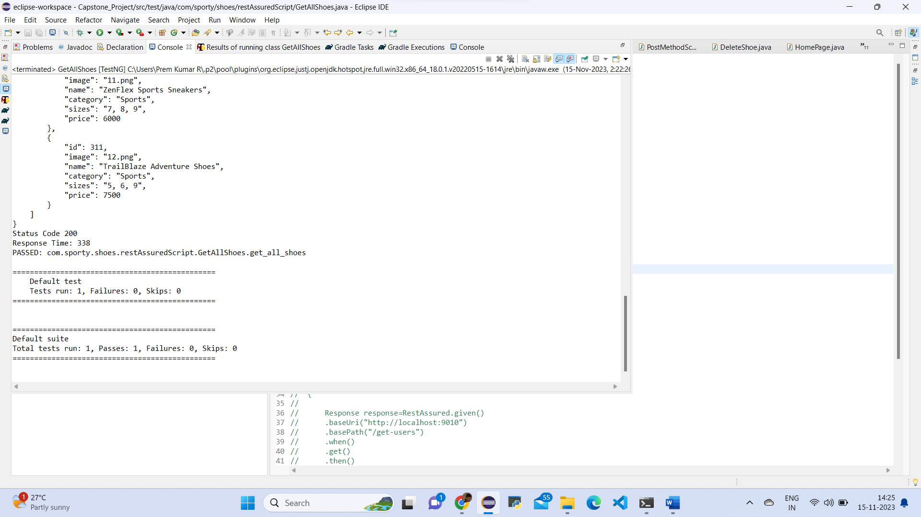

🡺Source Code:

=>Retrieve the list of all registered users.

**package** com.sporty.shoes.restAssuredScript;

**import** org.testng.Assert;

**import** org.testng.annotations.Test;

**import** io.restassured.response.Response;

**import** io.restassured.RestAssured;

**public** **class** GetAllShoes {

@Test(priority='2')

**public** **void** get_all_users()

{

Response response=RestAssured.*given*()

.baseUri("http://localhost:9010")

.basePath("/get-users")

.when()

.get()

.then()

.statusCode(200)

.extract()

.response();

System.***out***.println(response.getBody().asPrettyString());

System.***out***.println("Status Code " + response.getStatusCode());

System.***out***.println("Response Time: "+response.getTime());

**int** expectStatusCode = 200;

**int** ActualStatusCode = response.getStatusCode();

Assert.*assertEquals*(expectStatusCode, ActualStatusCode);

}

}

🡺ScreenShot:

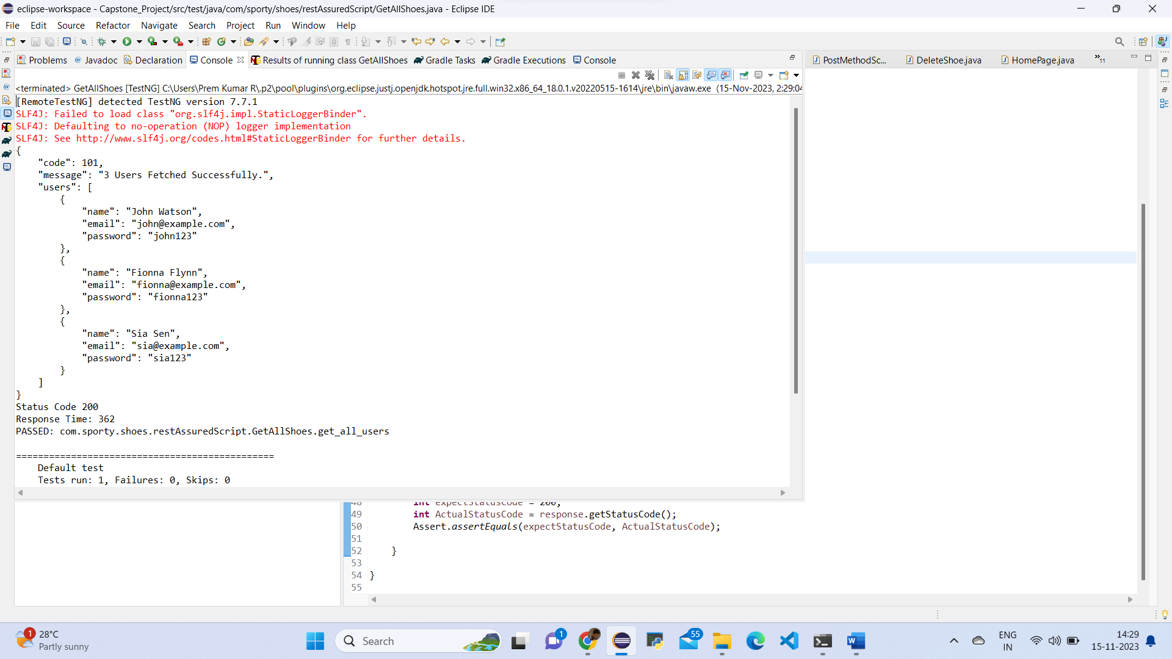

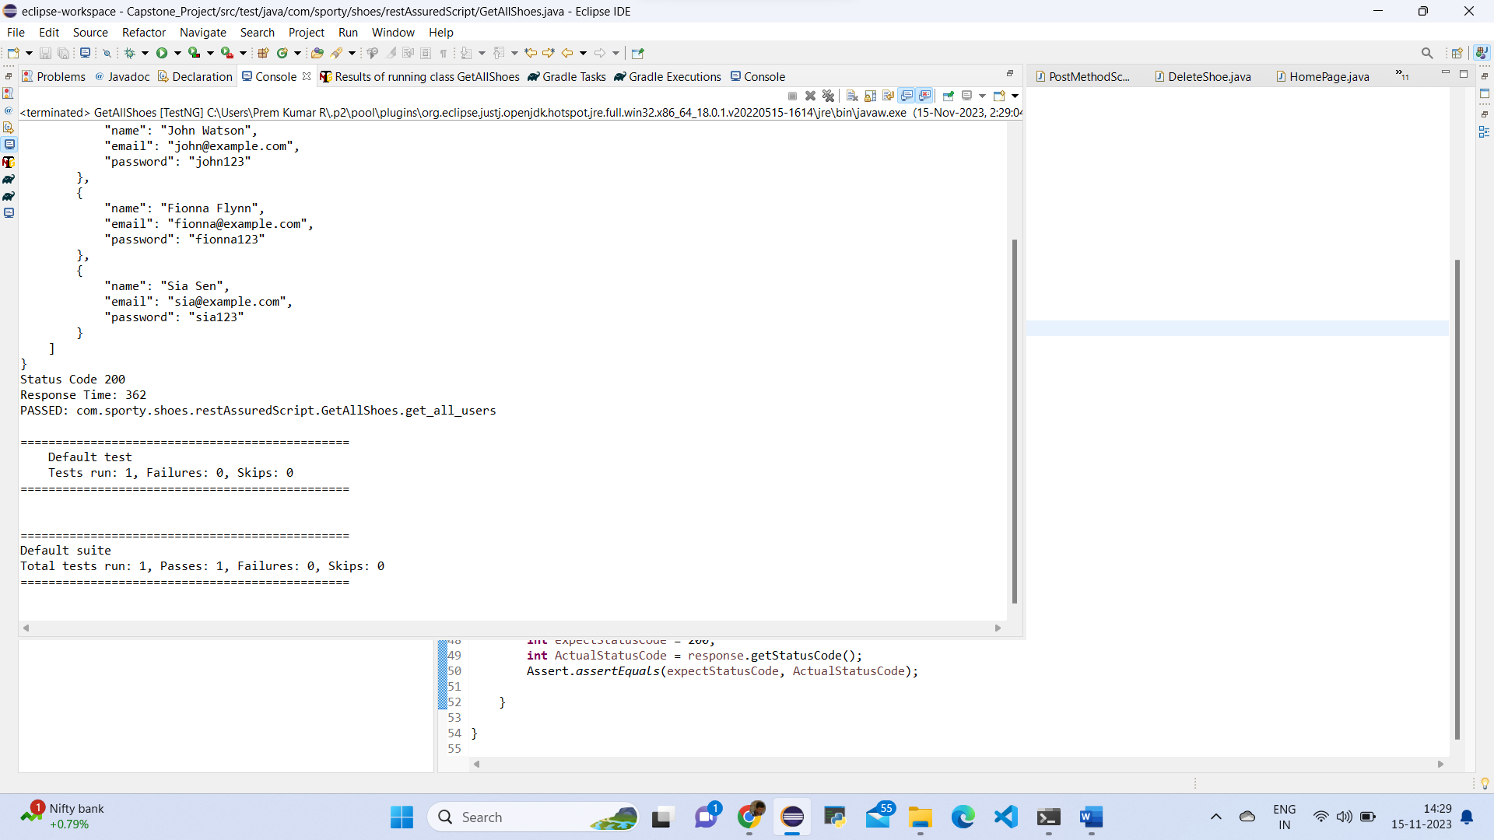

🡺Source Code:

=>Add the product.

package com.sporty.shoes.restAssuredScript;

import org.testng.Assert;

import io.restassured.RestAssured;

import io.restassured.response.Response;

public class PostNewShoes {

public void add_new_product()

{

Response response=RestAssured.given()

.baseUri("http://localhost:9010")

.basePath("/add-shoe")

.queryParam("id","1020")

.queryParam("image", "www.imge.com")

.queryParam("name","Nike")

.queryParam("category", "Running")

.queryParam("sizes","5,6,7")

.queryParam("price", "2000")

.when()

.post()

.then()

.extract()

.response();

System.out.println(response.getBody().asPrettyString());

System.out.println("Status Code" + response.getStatusCode());

System.out.println("Response Time: "+response.getTime());

int expectStatusCode = 200;

int ActualStatusCode = response.getStatusCode();

Assert.assertEquals(expectStatusCode, ActualStatusCode);

}

🡺Source Code:

=>Delete the product.

package com.sporty.shoes.restAssuredScript;

import org.testng.Assert;

import io.restassured.response.Response;

import org.testng.annotations.Test;

import io.restassured.RestAssured;

public class DeleteShoe {

@Test

public void delete_product()

{

Response response=RestAssured.given()

.baseUri("http://localhost:9010")

.basePath("/delete-shoe")

.queryParam("id", "1020")

.when().delete()

.then().extract()

.response();

System.out.println(response.getBody().asPrettyString());

System.out.println("Status Code " + response.getStatusCode());

System.out.println("Response Time: "+response.getTime());

int expectStatusCode = 200;

int ActualStatusCode = response.getStatusCode();

Assert.assertEquals(expectStatusCode, ActualStatusCode);

}

}

🡺ScreenShot:

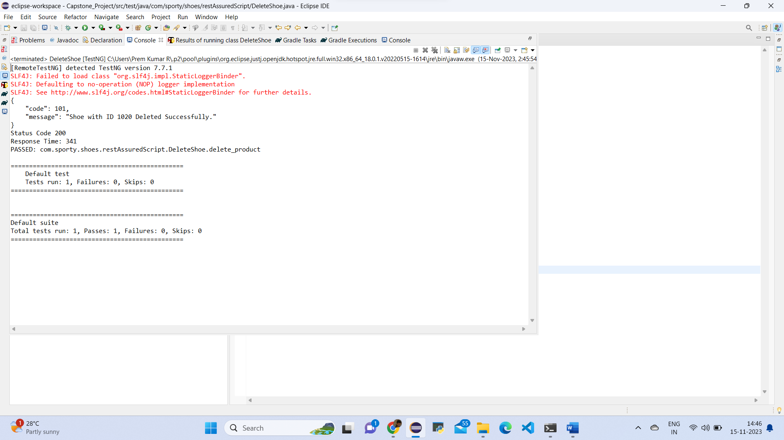

🡺Source Code:

=> Update the product.

package com.sporty.shoes.restAssuredScript;

import org.testng.Assert;

import org.testng.annotations.Test;

import io.restassured.response.Response;

import io.restassured.RestAssured;

public class PutNewShoes {

@Test

public void update_a_product()

{

Response response = RestAssured.given()

.baseUri("http://localhost:9010")

.basePath("/update-shoe")

.queryParam("id","1020")

.queryParam("image", "www.imge123.com")

.queryParam("name","Reebok")

.queryParam("category", "Running")

.queryParam("sizes","5,6,7")

.queryParam("price", "2500")

.when()

.put()

.then()

.statusCode(200)

.extract()

.response();

System.out.println(response.getBody().asPrettyString());

System.out.println("Status Code " + response.getStatusCode());

System.out.println("Response Time: "+response.getTime());

int expectStatusCode = 200;

int ActualStatusCode = response.getStatusCode();

Assert.assertEquals(expectStatusCode, ActualStatusCode);

}

}

🡺ScreenShot:

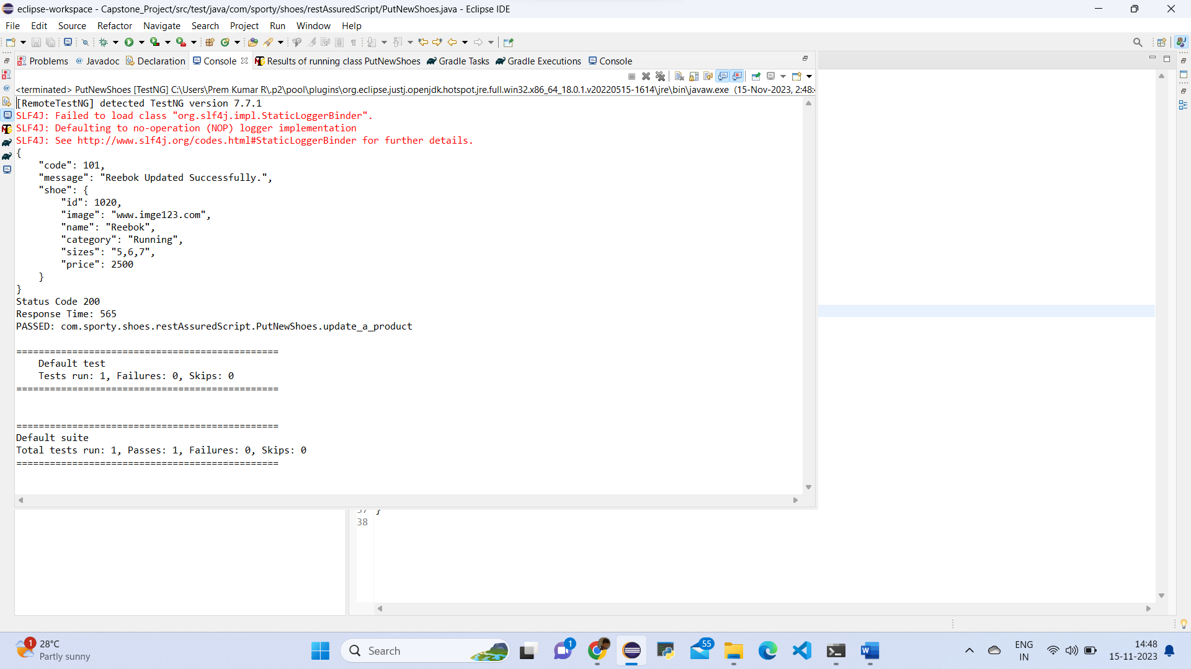

🡺Write Up:

1. Create Postman scripts to test the following API endpoints:

* Retrieve the list of all products in the store.
* Retrieve the list of all registered users.
* Add the product.
* Delete the product.
* Update the product.

**API Endpoints:**

|  |  |  |
| --- | --- | --- |
| Action | Method | Endpoint |
| Retrieve the list of all products in the store | GET | <http://localhost:9010/get-shoes> |
| Retrieve the list of all registered users | GET | <http://localhost:9010/get-users> |
| Add the product | POST | http://localhost:9010/add-shoe?id=101&image=image_url&name=SampleShoe&category=Running&sizes=9&price=1000 |
| Delete the product | DELETE | <http://localhost:9010/delete-shoe?id=101> |
| Update the product | PUT | [http://localhost:9010/update-shoe](http://localhost:9010/add-shoe) |

* Create a Capstone Project in Postman

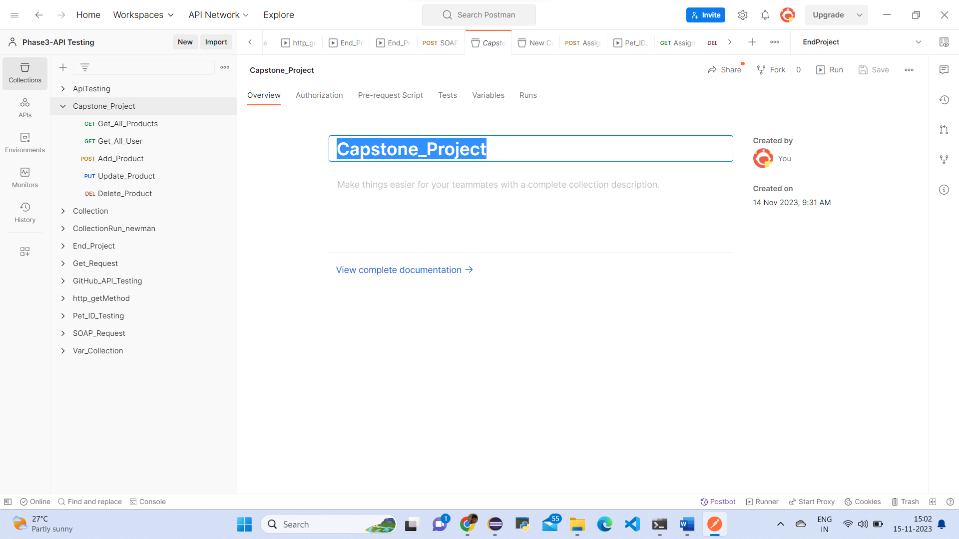

* Retrieve the list of all products in the store

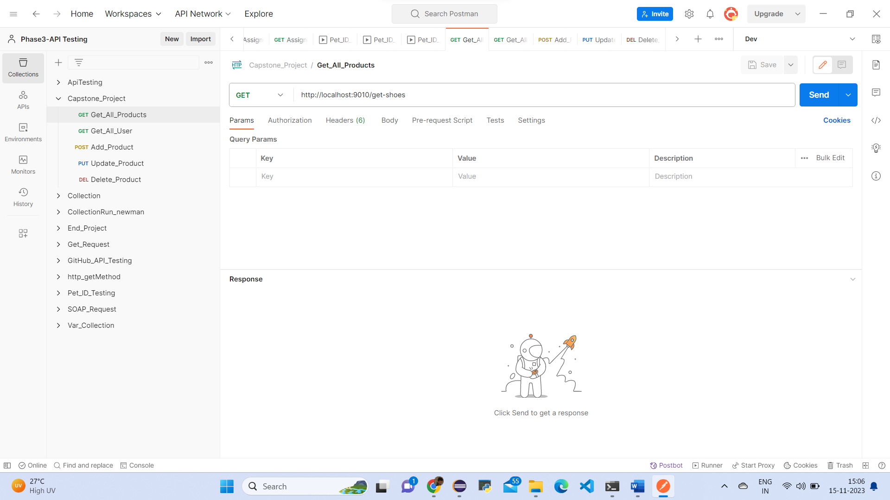

Response

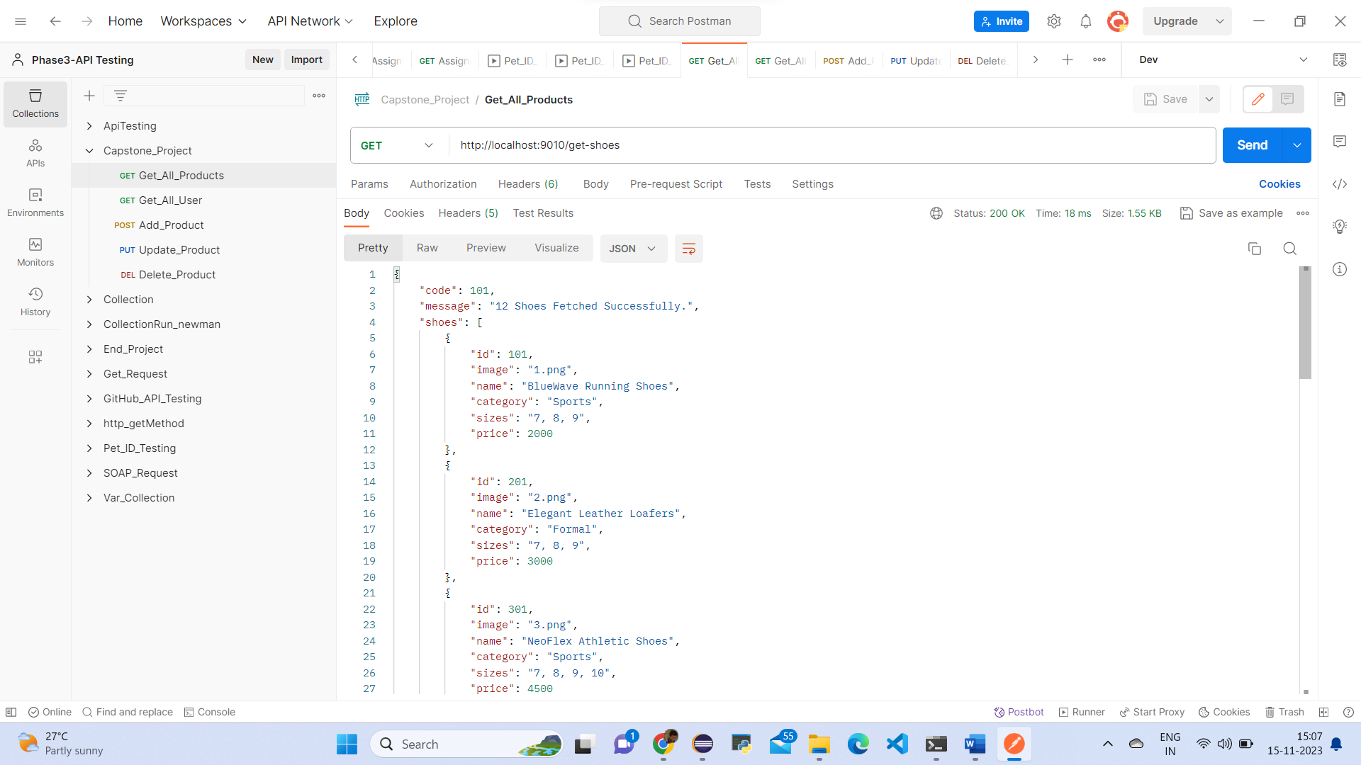

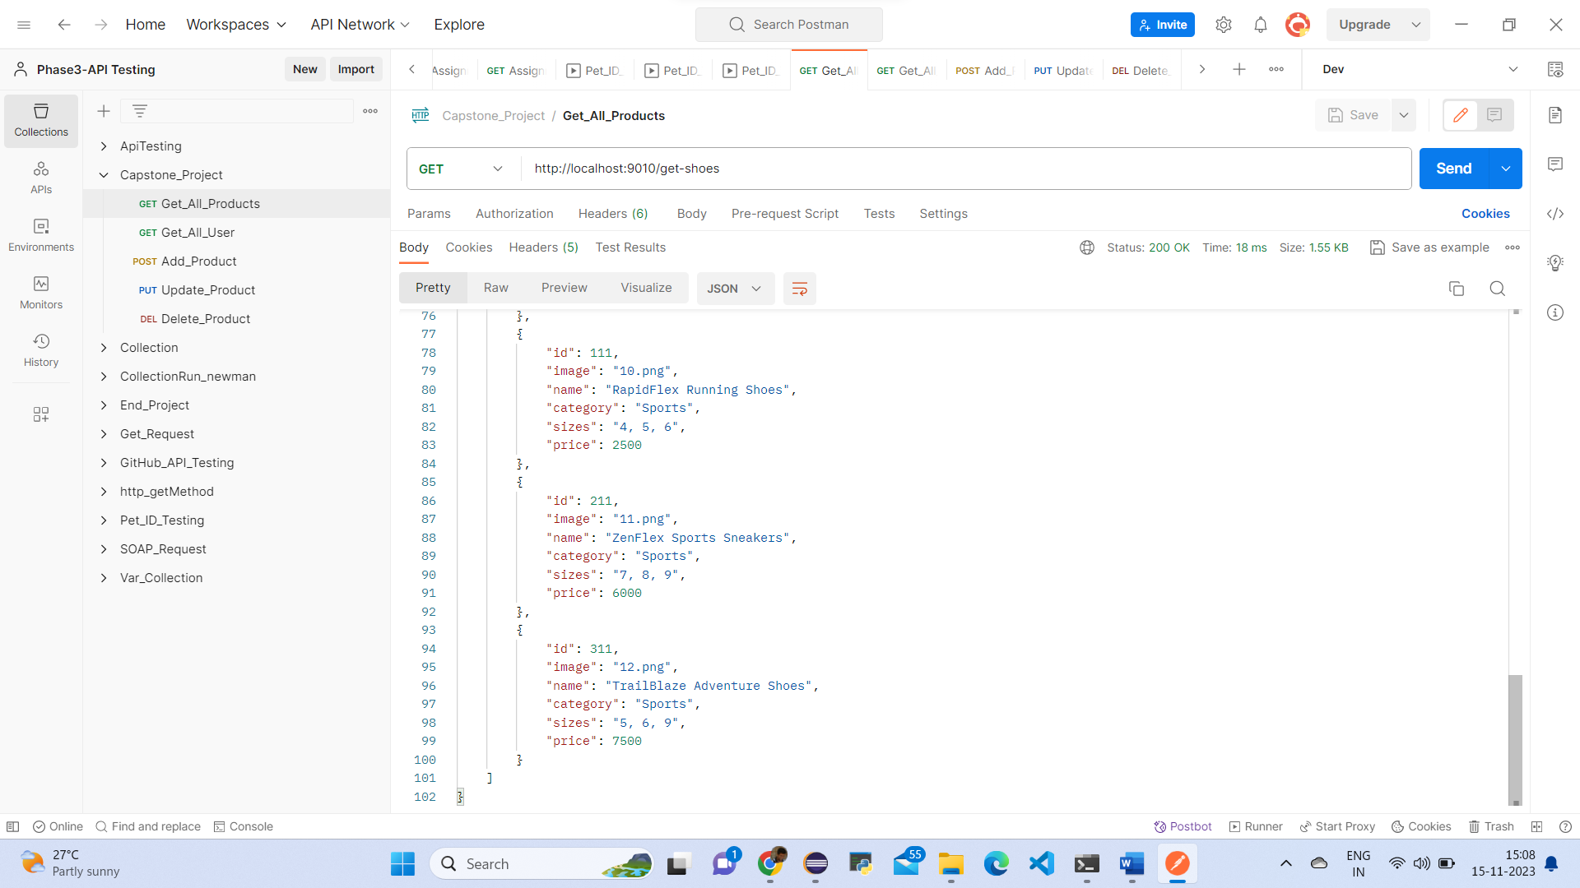

* Retrieve the list of all registered users.

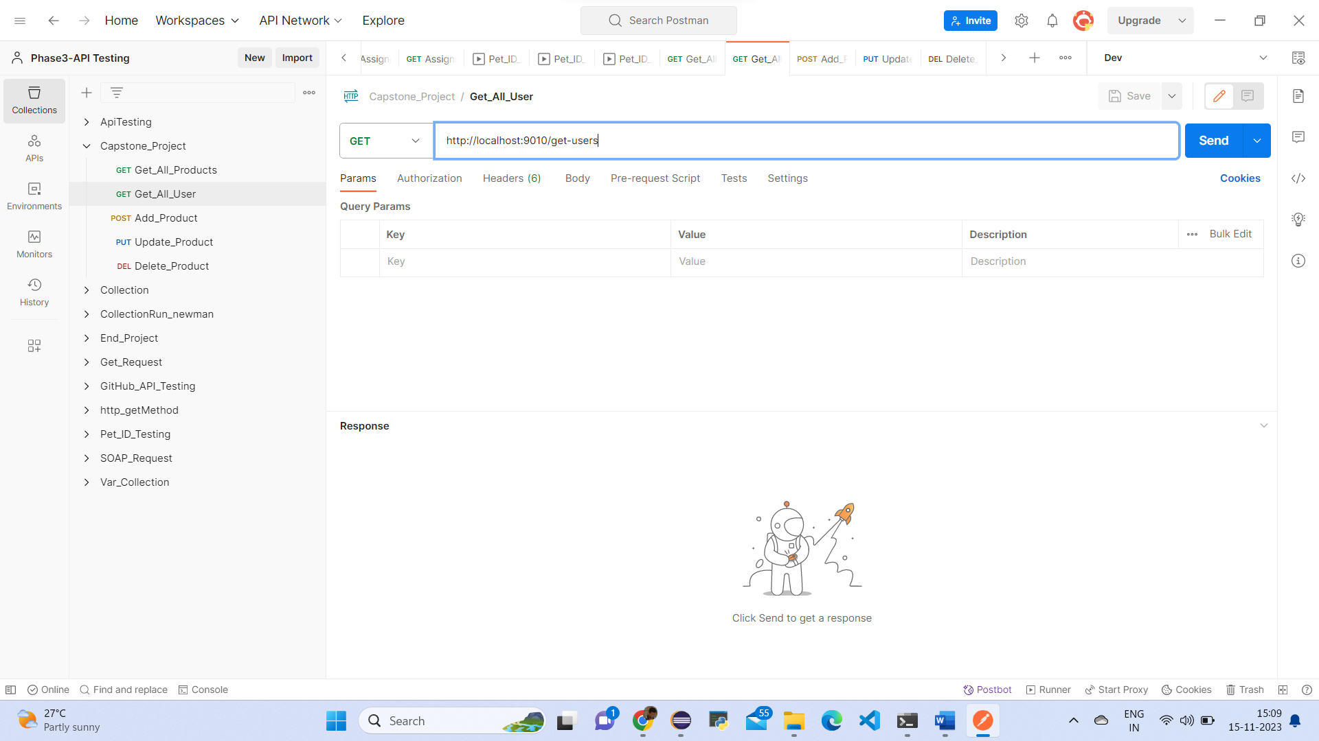

Response of all registered users.

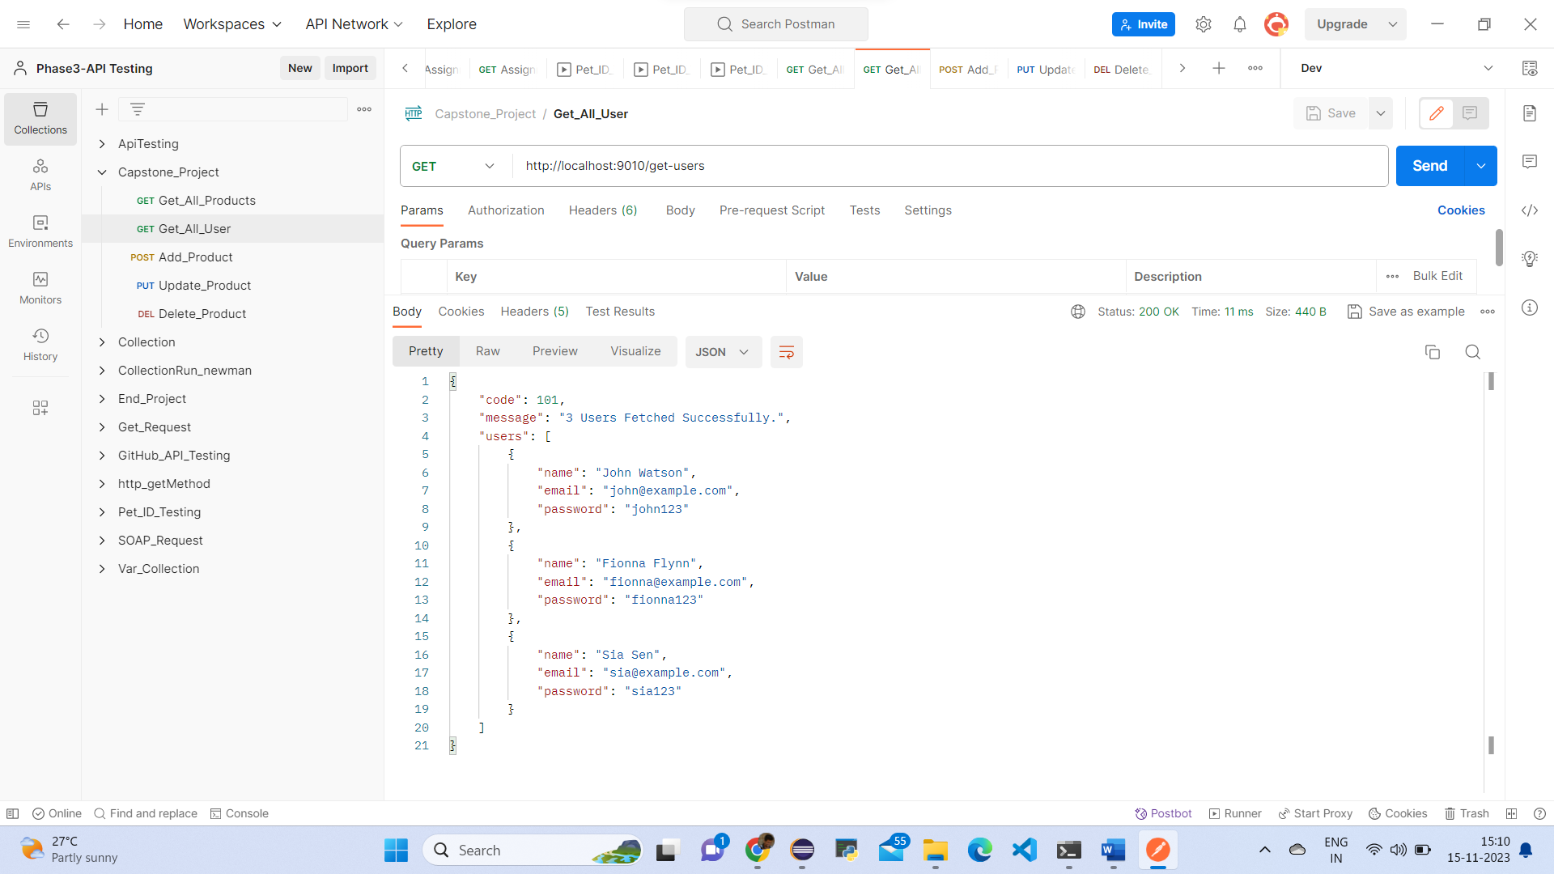

* Add the product.

<http://localhost:9010/add-shoe?id=101&image=image_url&name=SampleShoe&category=Running&sizes=9&price=1000>

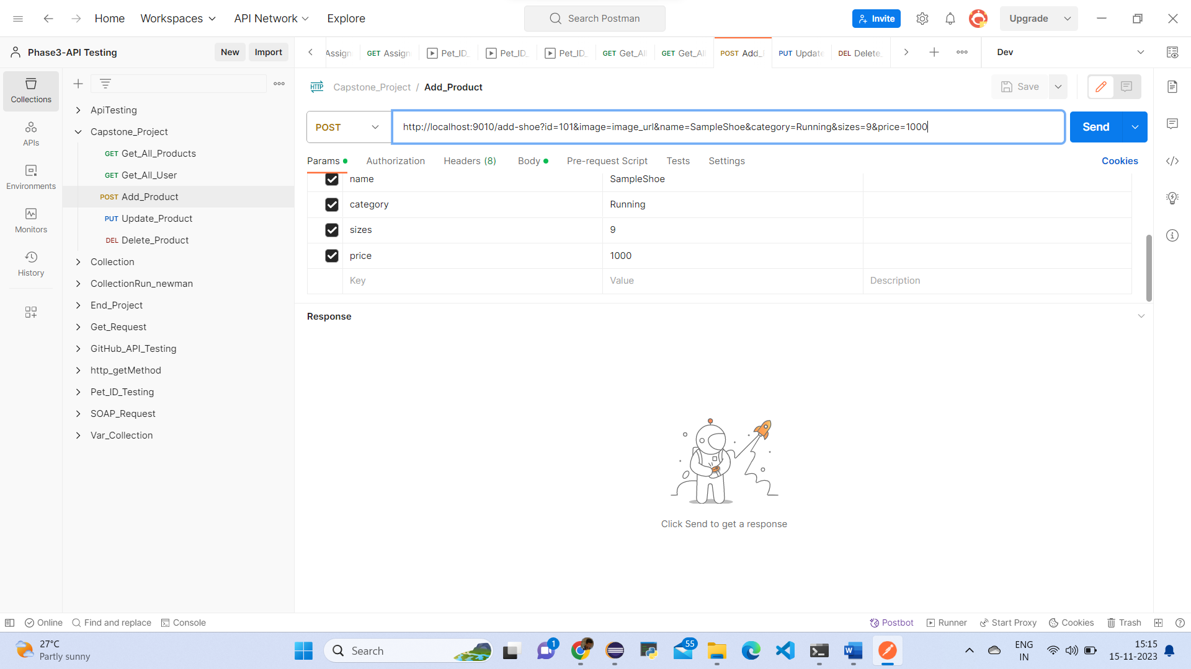

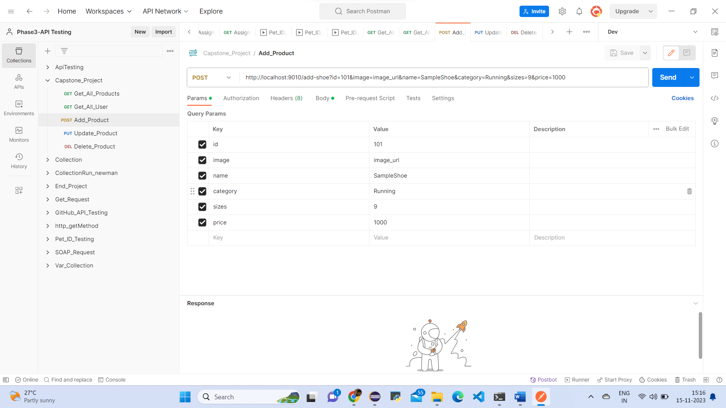

Response of add product.

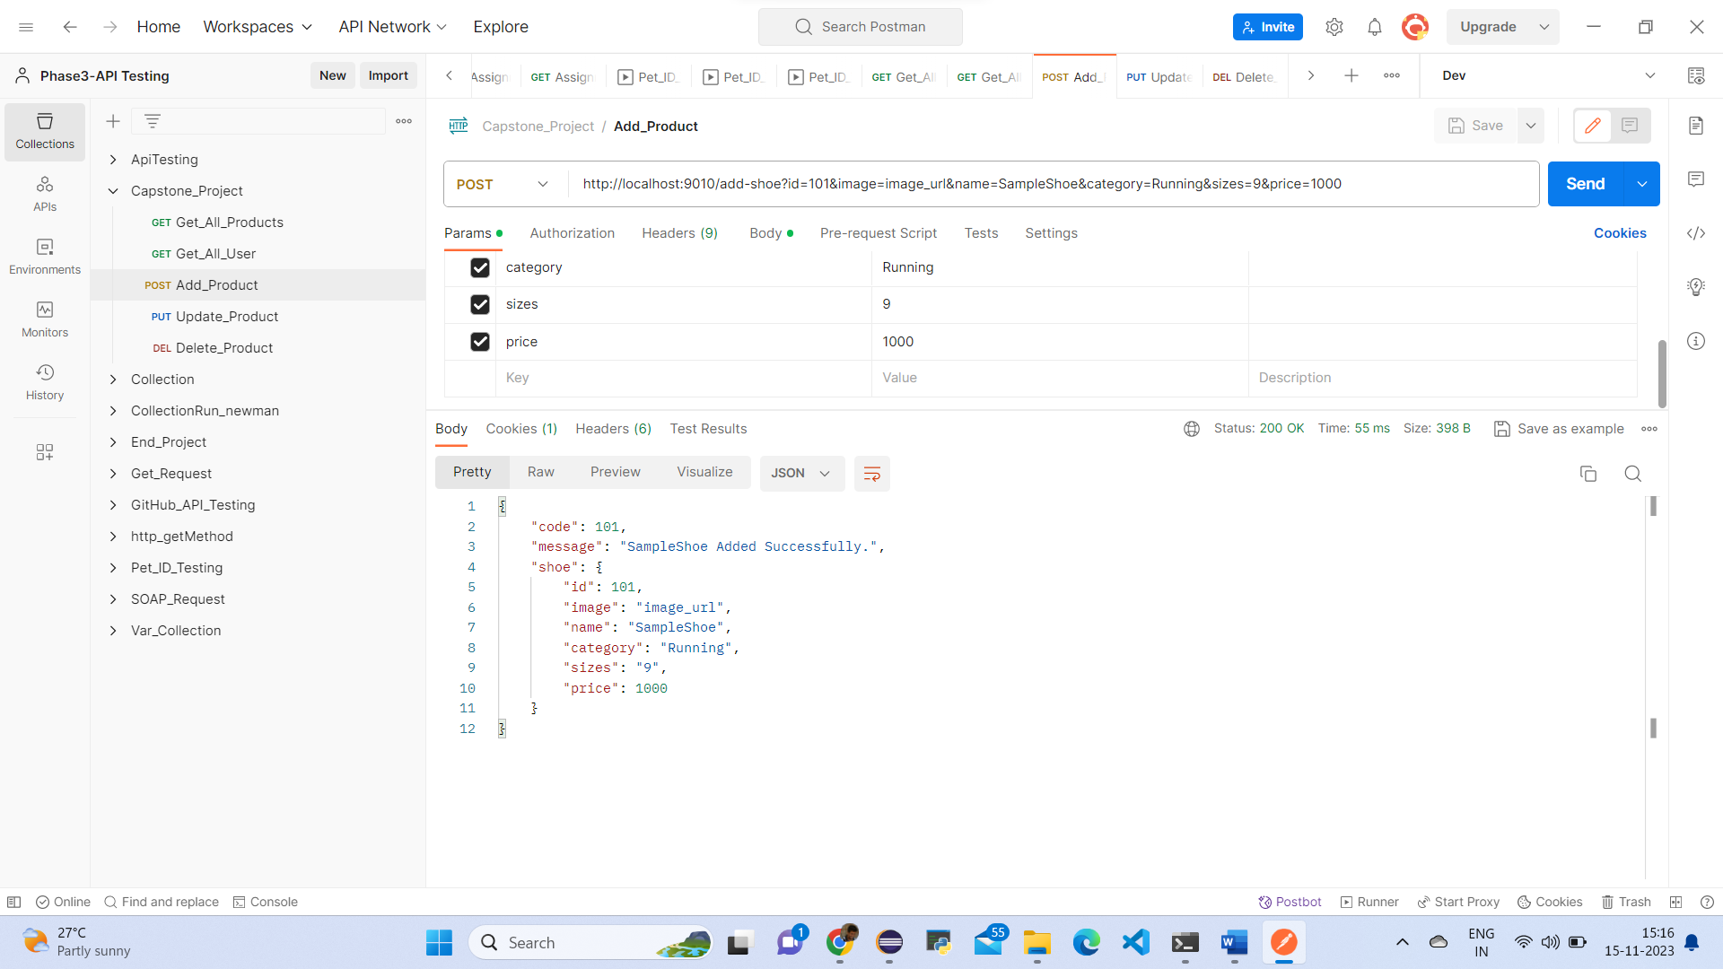

**Update Product URL Sample with PUT Method:**

**Request body** ([http://localhost:9010/update-shoe](http://localhost:9010/add-shoe))

{

"id": 101,

"name": "Updated Shoe Name",

"category": "Updated Category",

"sizes": "8,9,10",

"price": 1500

"image": "updated_image_url",

}

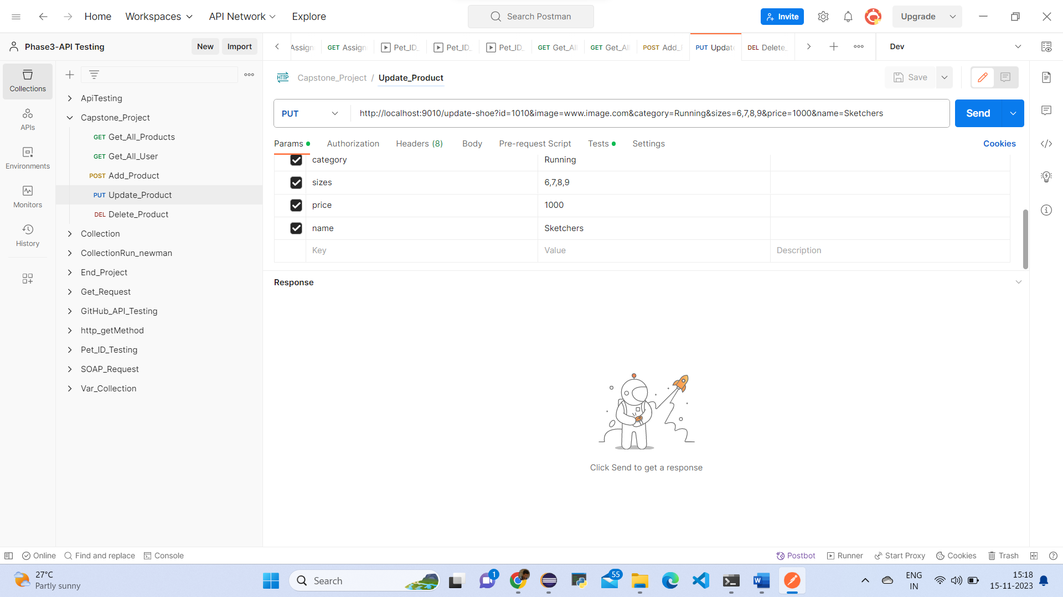

Response of update product.

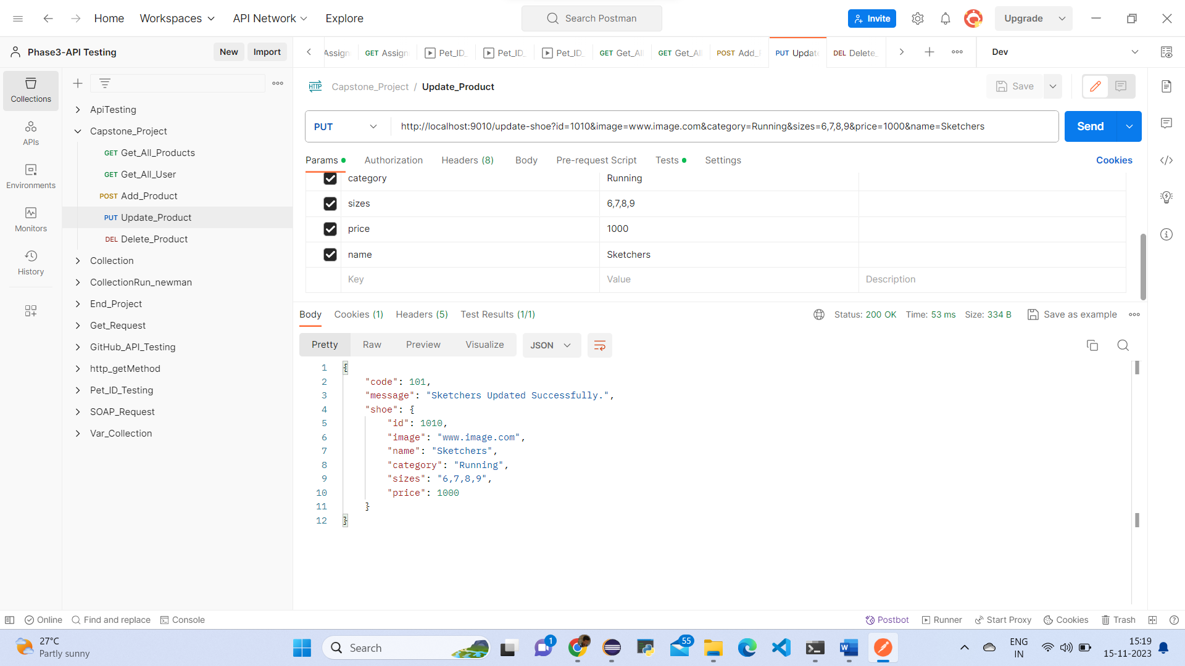

**Delete Product URL Sample with DELETE Method:**

<http://localhost:9010/delete-shoe?id=101>

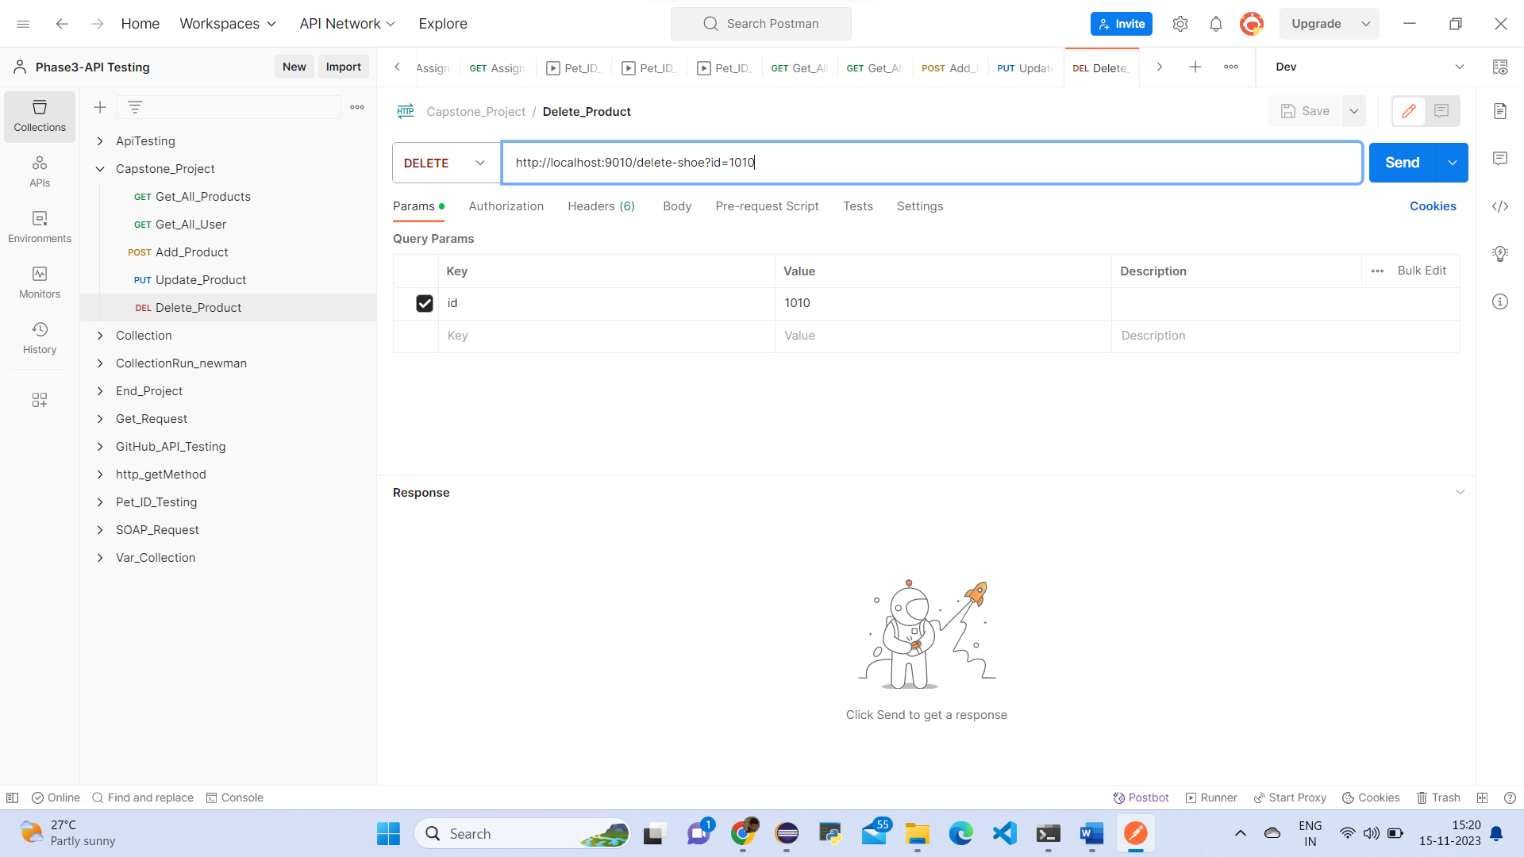

Response of delete product.

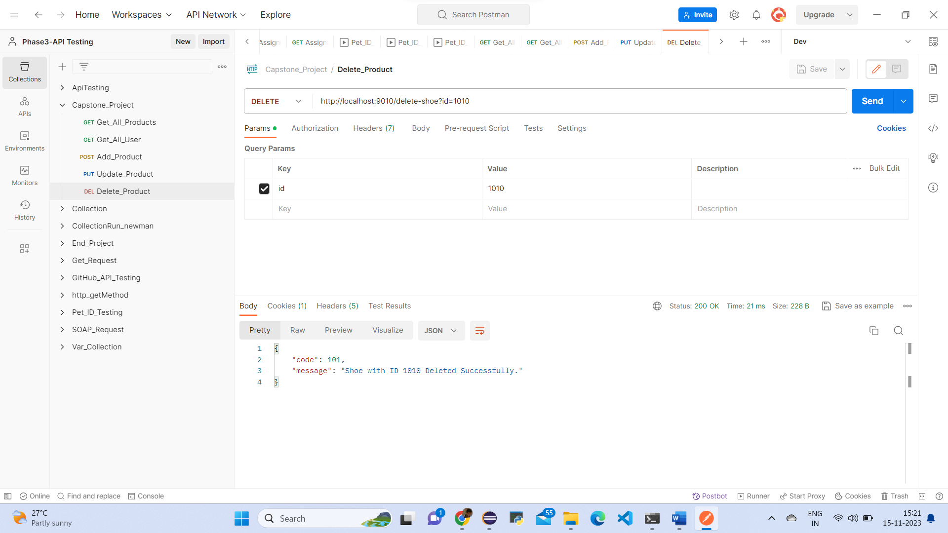

3.Create JMeter scripts to do load testing of the homepage and the product detail page.

Add🡪Thread🡪Thread Group

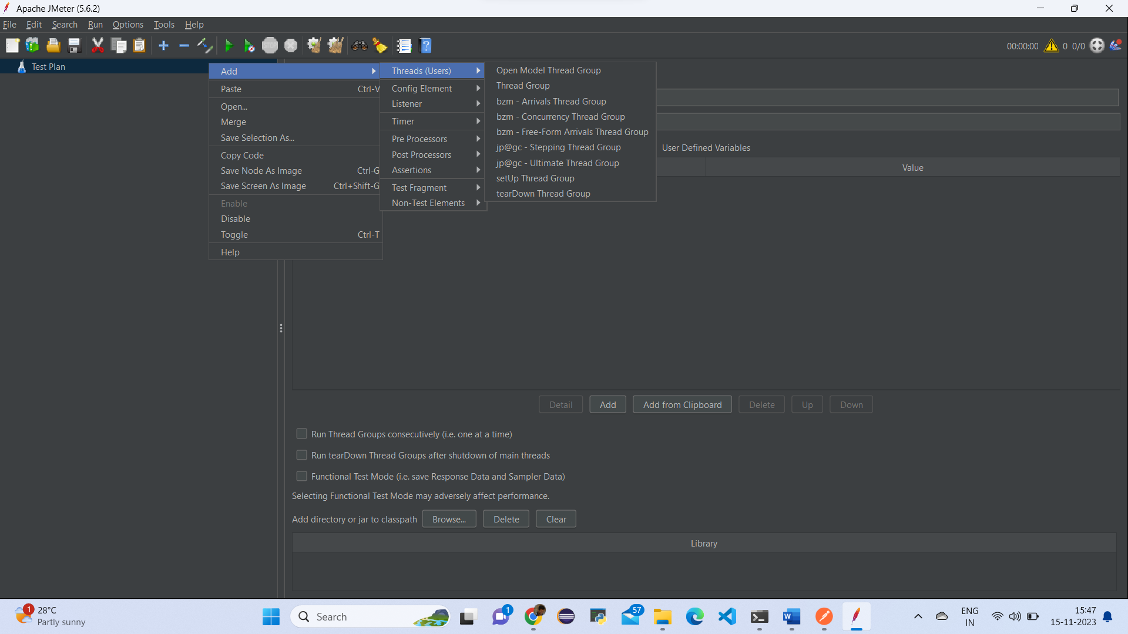

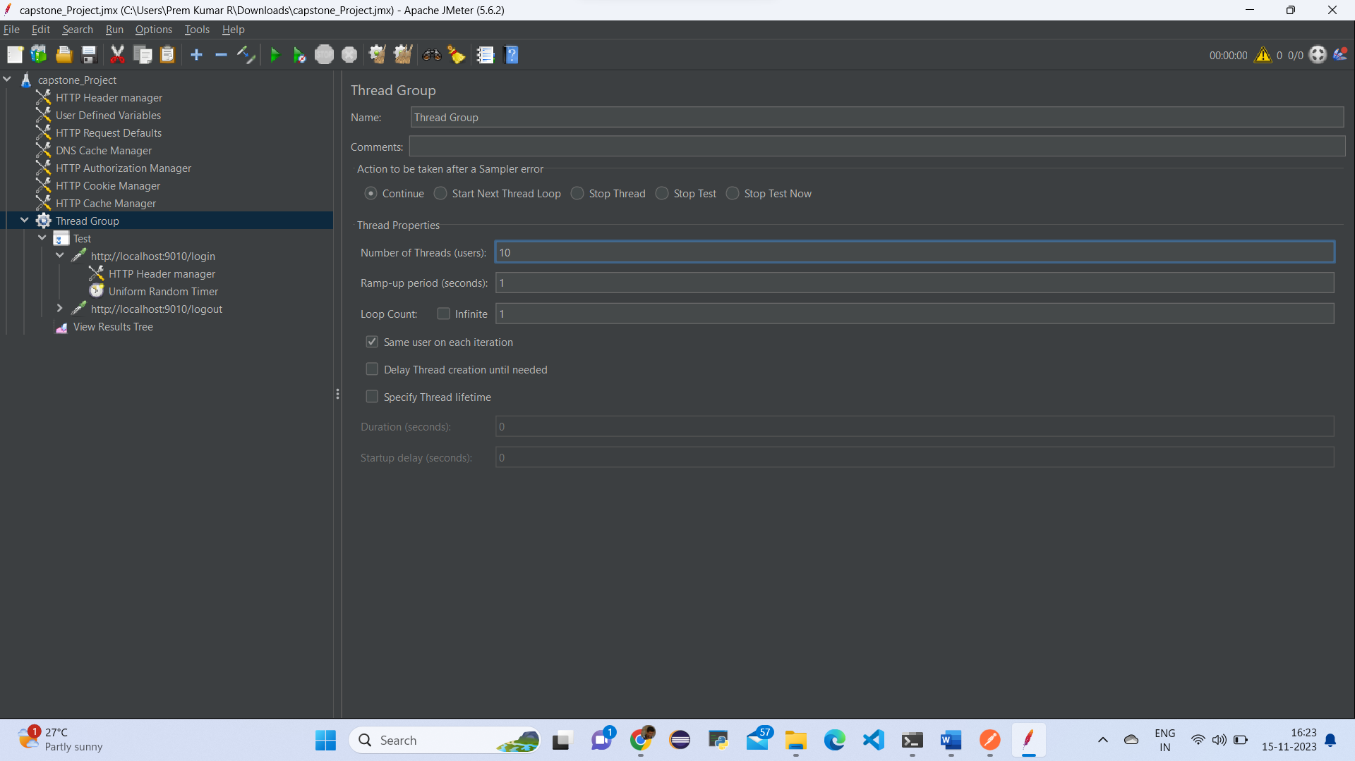

Test Plan🡪Add🡪Non-Test Elements🡪Http Script Recorder

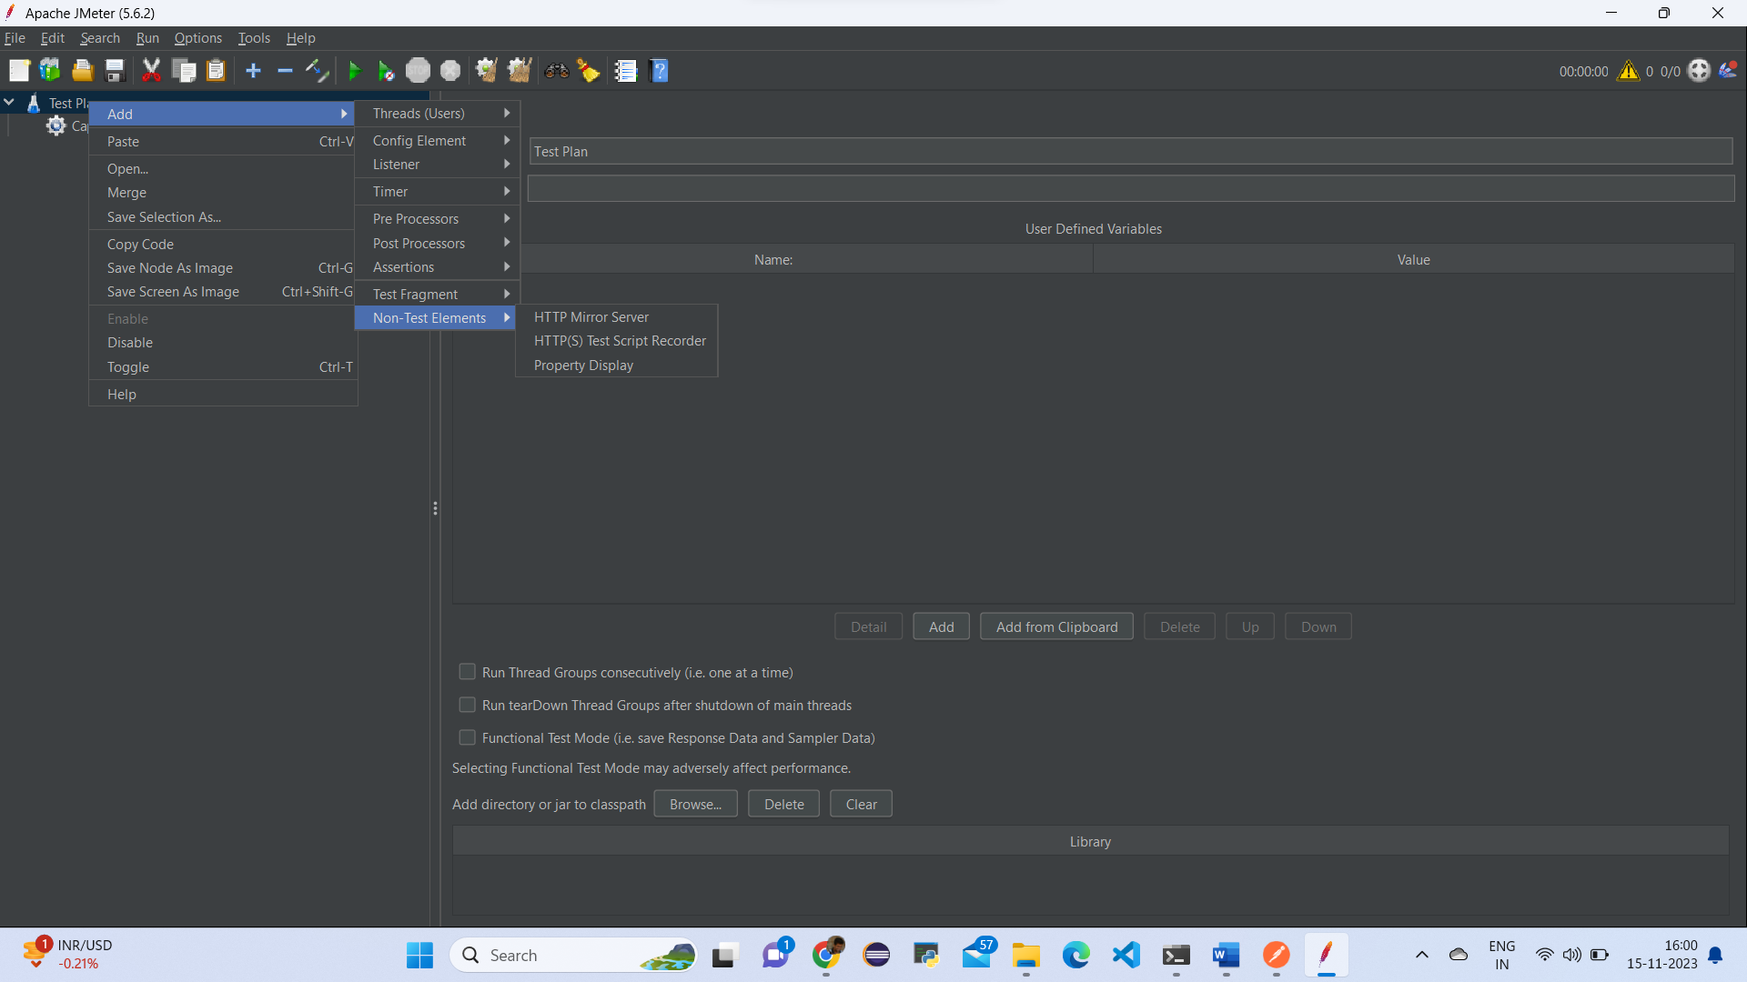

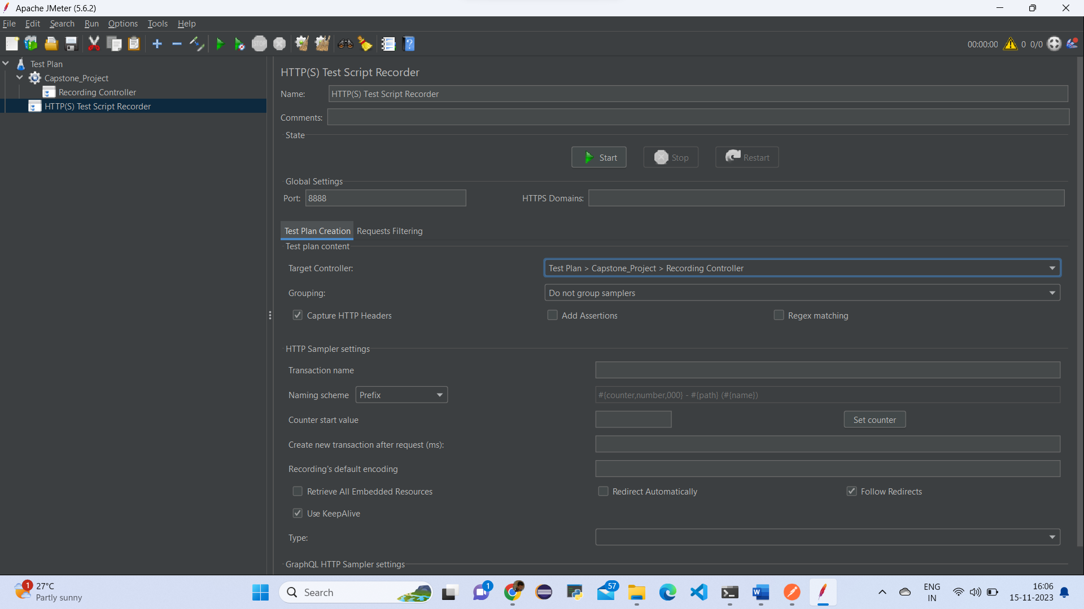

Thread Group🡪Add🡪Logic Controller🡪Recording Controller

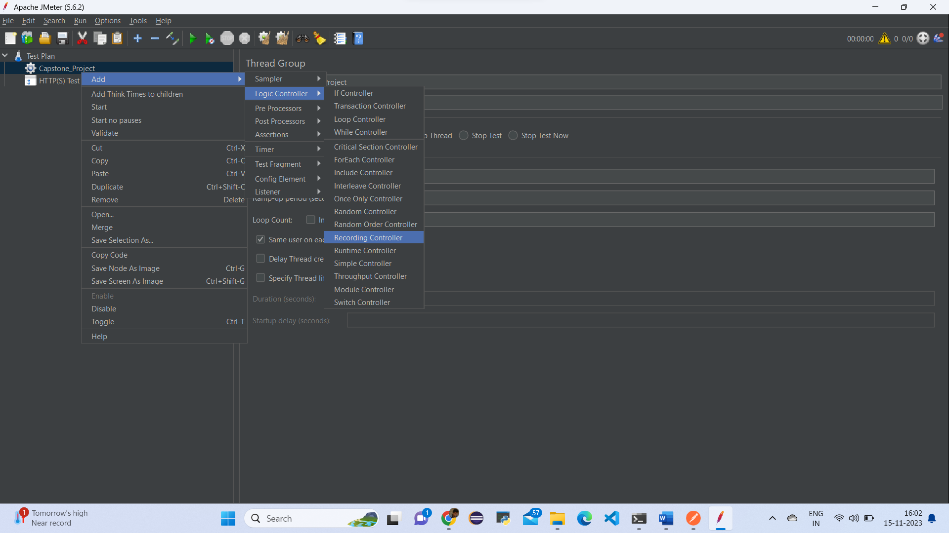

Login Page

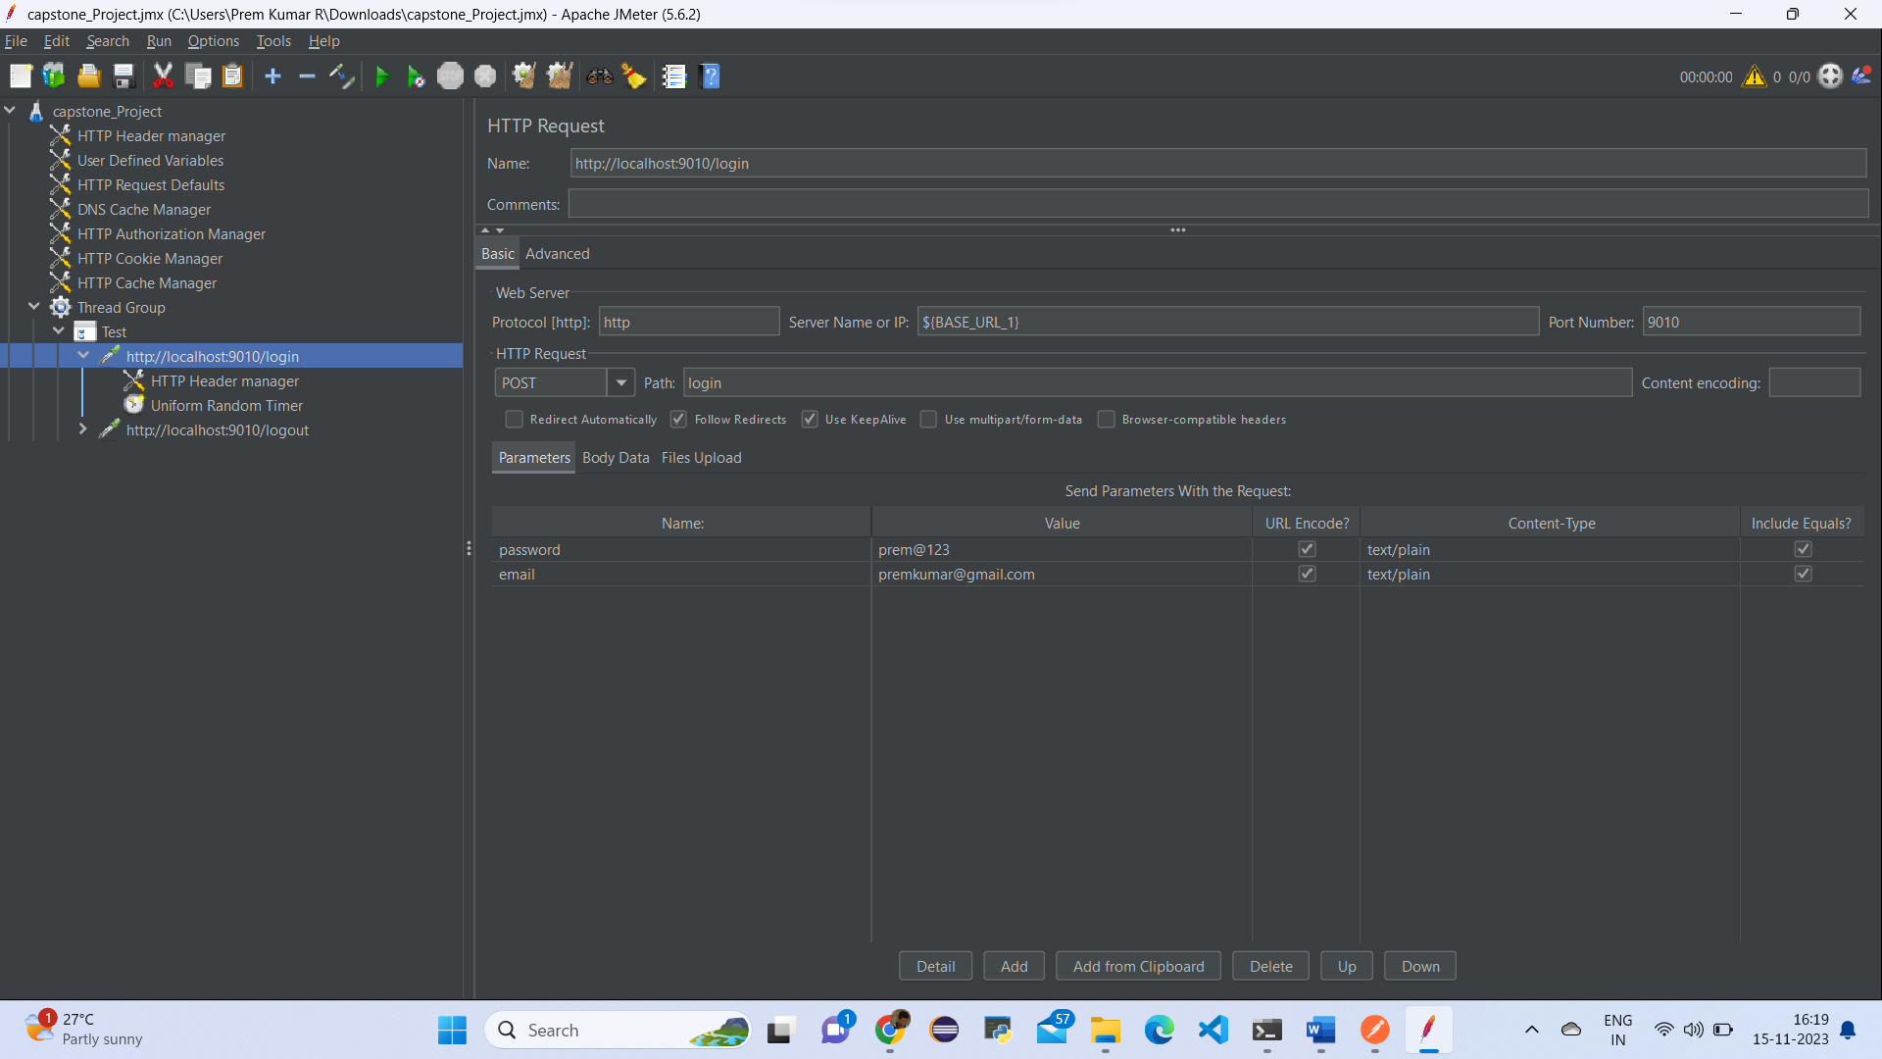

Logout

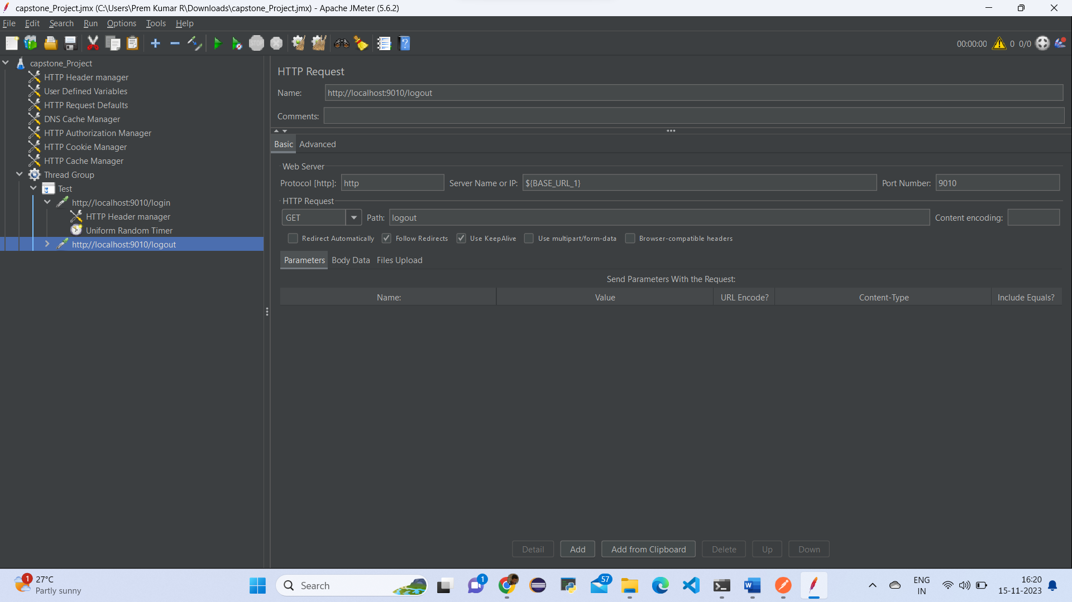

Output:

Thread Group🡪Add🡪Listener🡪View Result Tree

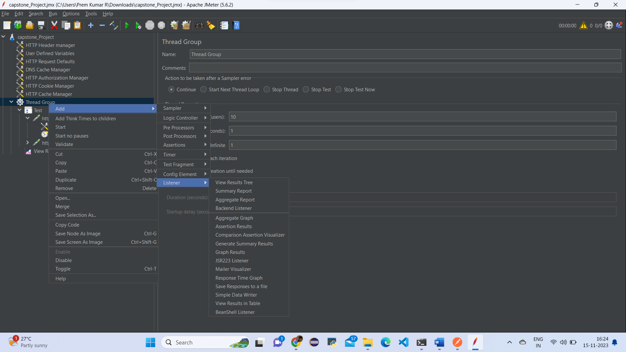

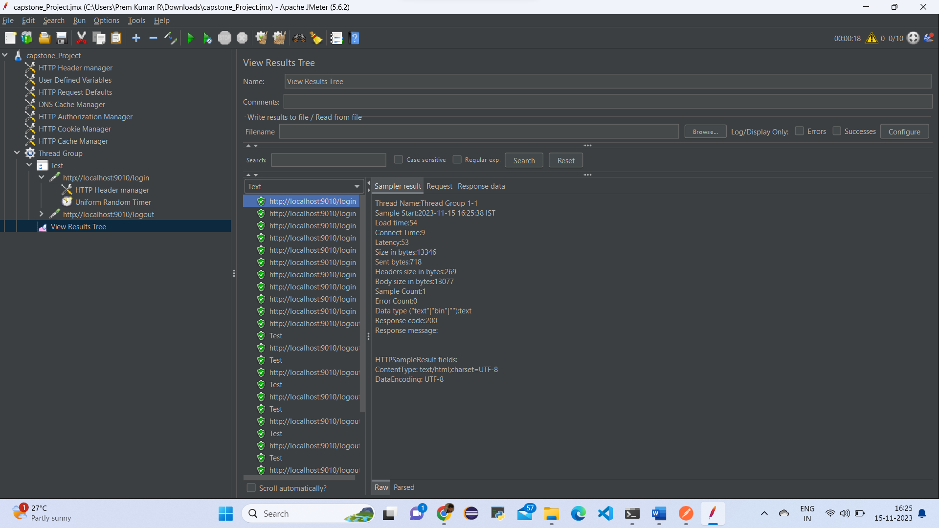

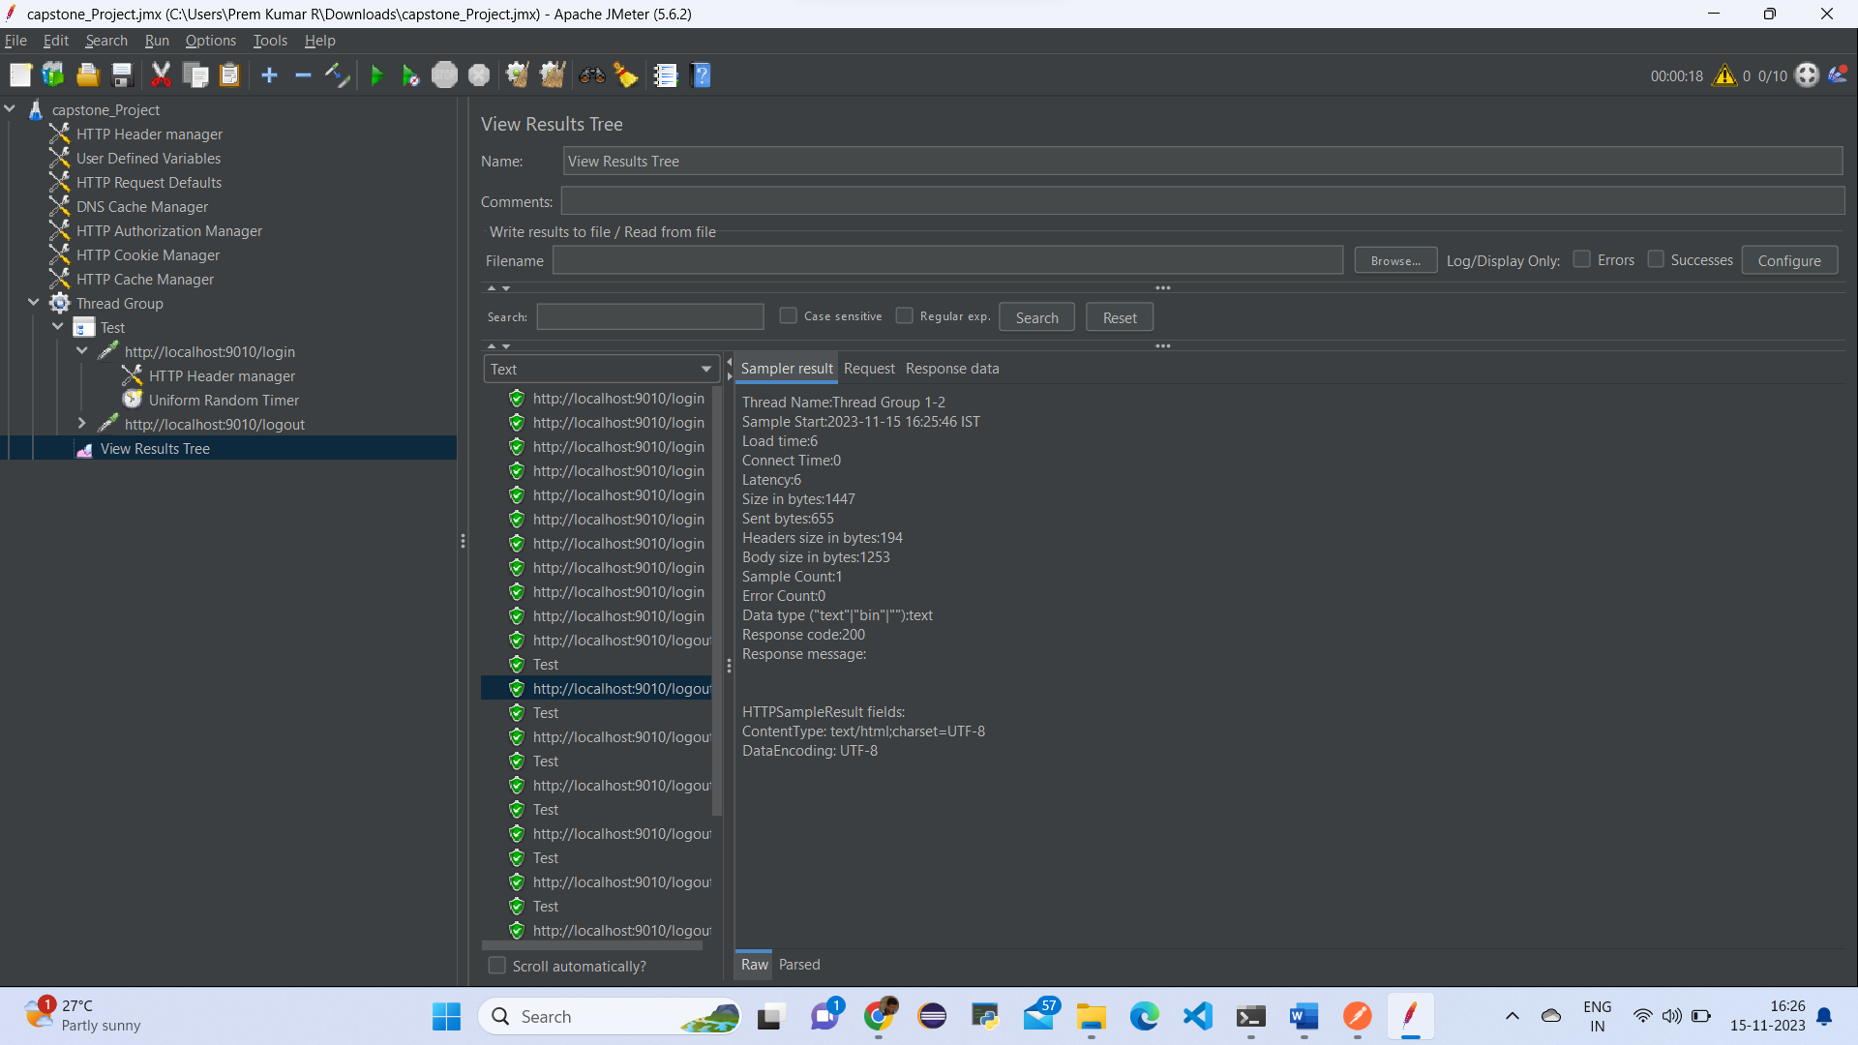

4. Create Selenium scripts using TestNG to test all the pages in the web app that will automate:

* Login page
* Registration Page
* Add Product to cart page.
* Place Order Page

First go to eclipse create a package com.sportyshoe.seleniumcucumberscripts Under class setupcheck.java

Source Code:

package com.sporty.shoes.SeleniumCucumberScripts;

import org.openqa.selenium.By;

import org.openqa.selenium.WebDriver;

import org.openqa.selenium.chrome.ChromeDriver;

import org.testng.annotations.Test;

public class SetUpCheck {

@Test

public void test_setup_selenium()

{

WebDriver driver = new ChromeDriver();

driver.manage().window().maximize();

driver.get("http://localhost:9010/");

String text = driver.findElement(By.xpath("//div[@class='container mt-3']/descendant::p[1]")).getText();

System.out.println(text);

System.out.println(driver.getTitle());

}

}

ScreenShot:

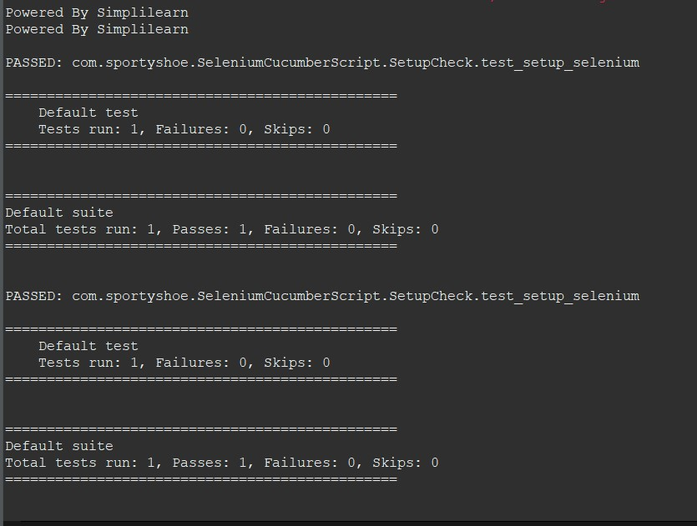

Next go to another class name as TestBase

Source Code:

package com.sporty.shoes.SeleniumCucumberScripts;

import org.openqa.selenium.WebDriver;

import org.openqa.selenium.chrome.ChromeDriver;

import org.openqa.selenium.firefox.FirefoxDriver;

public class TestBase {

public static WebDriver driver;

public static void OpenBrowser(String browser)

{

if(browser == "Chrome")

{

driver = new ChromeDriver();

}

if(browser == "FireFox")

{

driver = new FirefoxDriver();

}

driver.manage().window().maximize();

driver.manage().deleteAllCookies();

driver.get("http://localhost:9010/");

}

public static void closebrowser()

{

driver.close();

}

}

**ScreenShot:**

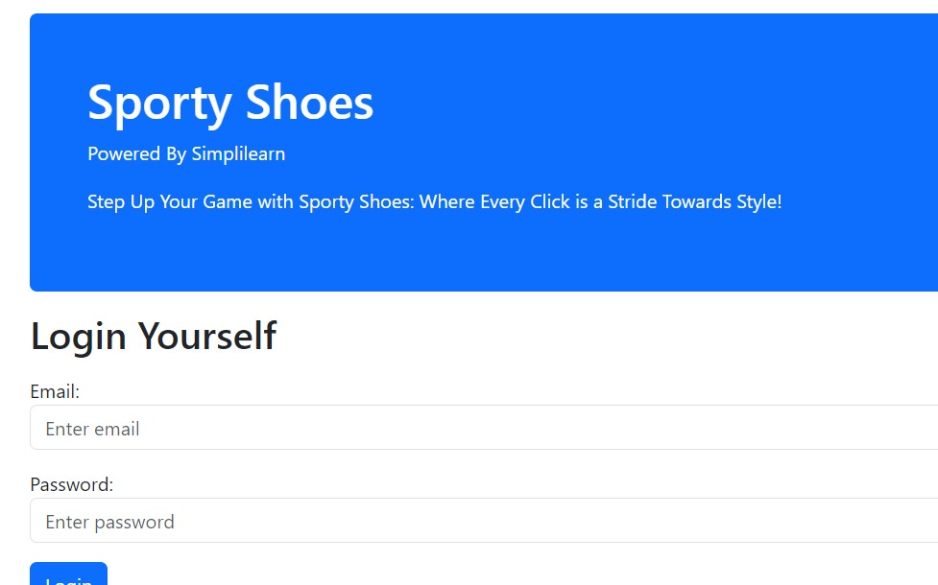

Next go to another class name as HomePage

Source Code:

package com.sporty.shoes.SeleniumCucumberScripts;

import org.openqa.selenium.WebDriver;

import org.openqa.selenium.WebElement;

import org.openqa.selenium.support.FindBy;

import org.openqa.selenium.support.PageFactory;

public class HomePage extends TestBase {

@FindBy(xpath="//div[@class='container mt-3']/descendant::p[1]")

WebElement text;

@FindBy(linkText="New User? Register Here")

WebElement registerLink;

public HomePage(WebDriver driver) {

PageFactory.initElements(driver, this);

}

public String getURL_page()

{

String URLnew = driver.getCurrentUrl();

return URLnew;

}

public String Validate_Text_On_Page()

{

String pageText = text.getText();

System.out.println(pageText);

return pageText;

}

public void click_register_link()

{

registerLink.click();

}

}

ScreenShot:

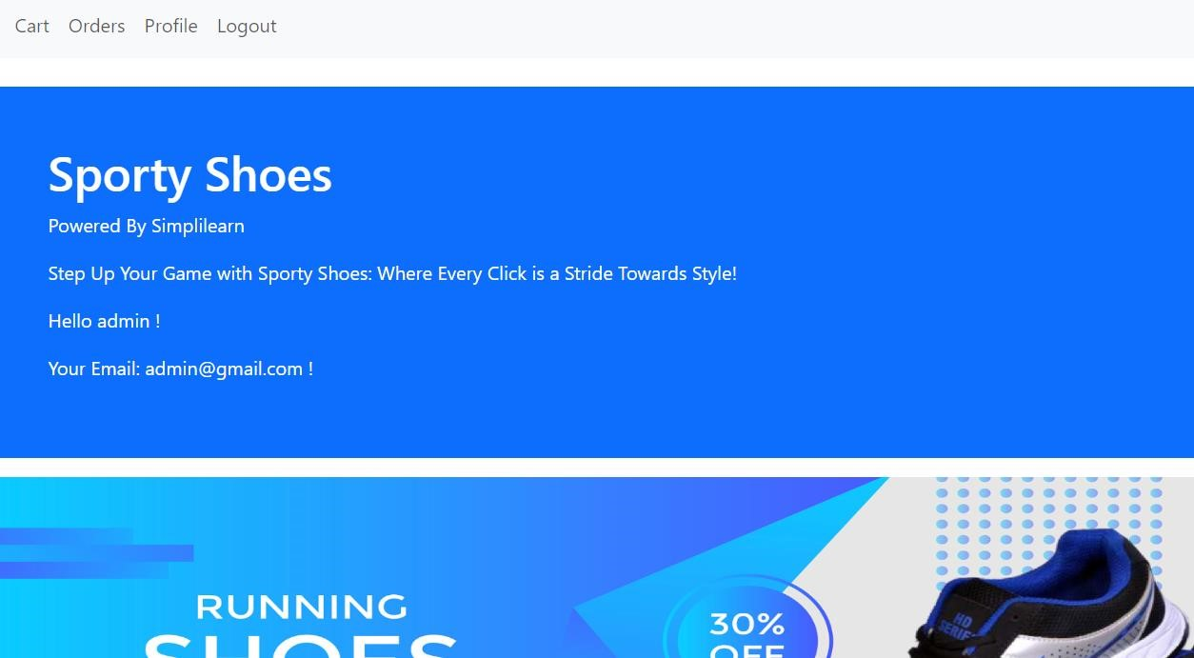

Next add another class Login Page under same package:

Source Code:

package com.sporty.shoes.SeleniumCucumberScripts;

import org.openqa.selenium.WebDriver;

import org.openqa.selenium.WebElement;

import org.openqa.selenium.support.FindBy;

import org.openqa.selenium.support.PageFactory;

public class LoginPage {

@FindBy(xpath="//input[@id='email']")

WebElement loginEmail;

@FindBy(xpath="//input[@id='password']")

WebElement loginpassword;

@FindBy(xpath="//button[@type='submit']")

WebElement loginbtn;

@FindBy(linkText="Cart")

WebElement clickCart;

public LoginPage(WebDriver driver) {

PageFactory.initElements(driver, this);

}

public void user_login()

{

loginEmail.sendKeys("admin@gmail.com.com");

loginpassword.sendKeys("admin@123");

loginbtn.click();

}

public void click_cart()

{

clickCart.click();

}

}

**ScreenShot:**

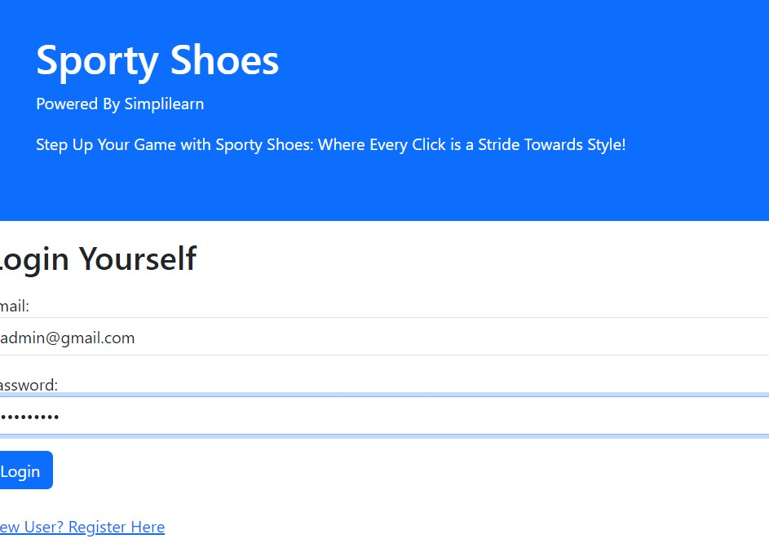

Next add another class under same package name as Register Page

Source Code:

package com.sporty.shoes.SeleniumCucumberScripts;

import org.openqa.selenium.WebDriver;

import org.openqa.selenium.WebElement;

import org.openqa.selenium.support.FindBy;

import org.openqa.selenium.support.PageFactory;

public class RegisterPage extends TestBase{

@FindBy(xpath="//input[@id='name']")

WebElement registername;

@FindBy(xpath="//input[@id='email']")

WebElement registeremail;

@FindBy(xpath="//input[@id='password']")

WebElement registerpassword;

@FindBy(xpath="//button[@type='submit']")

WebElement registerBtn;

@FindBy(xpath="//div[@class='mt-4 p-5 bg-primary text-white rounded']/descendant::p[3]")

WebElement userText;

public RegisterPage(WebDriver driver) {

PageFactory.initElements(driver, this);

}

public void register_user()

{

registername.sendKeys("admin");

registeremail.sendKeys("admin@gmail.com");

registerpassword.sendKeys("admin@123");

registerBtn.click();

}

public String validate_registration_URL()

{

String register_url = driver.getCurrentUrl();

return register_url;

}

public String validate_registration_Text()

{

String user_name = userText.getText();

return user_name;

}

}

ScreenShot:

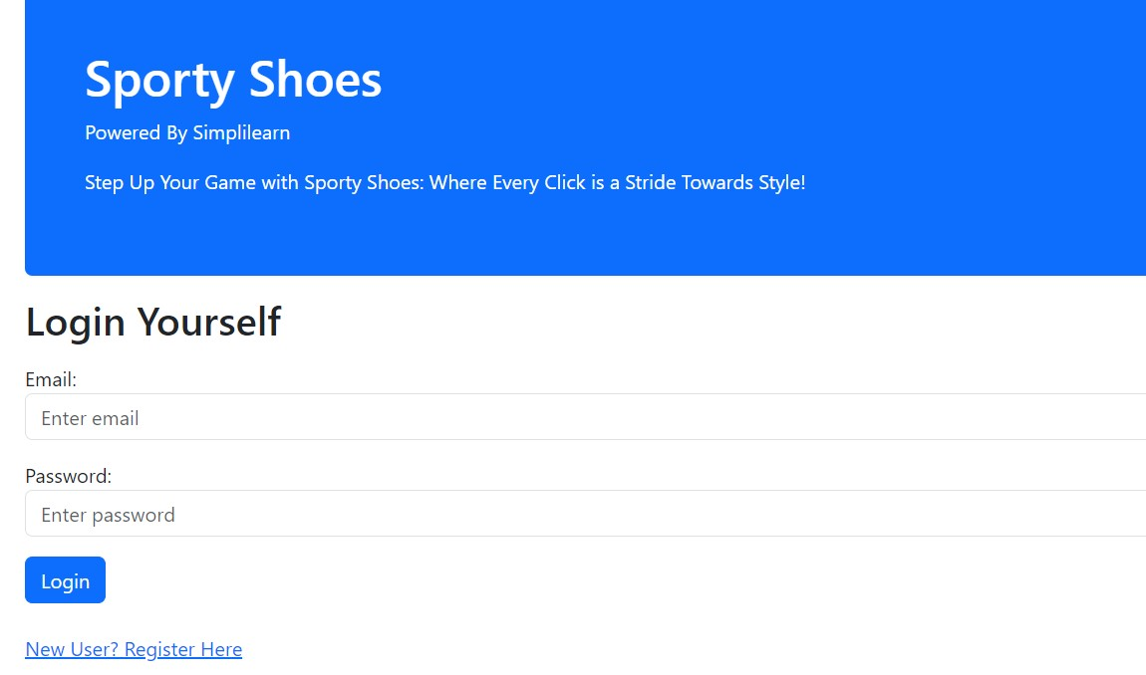

Next add another class name as orderPage under the same

package com.sporty.shoes.SeleniumCucumberScripts;

import org.openqa.selenium.WebDriver;

import org.openqa.selenium.WebElement;

import org.openqa.selenium.support.FindBy;

import org.openqa.selenium.support.PageFactory;

public class OrderPage {

@FindBy(linkText="Orders")

WebElement orderlink;

public OrderPage(WebDriver driver) {

PageFactory.initElements(driver, this);

}

public void click_orderPage()

{

orderlink.click();

}

}

**Output:**

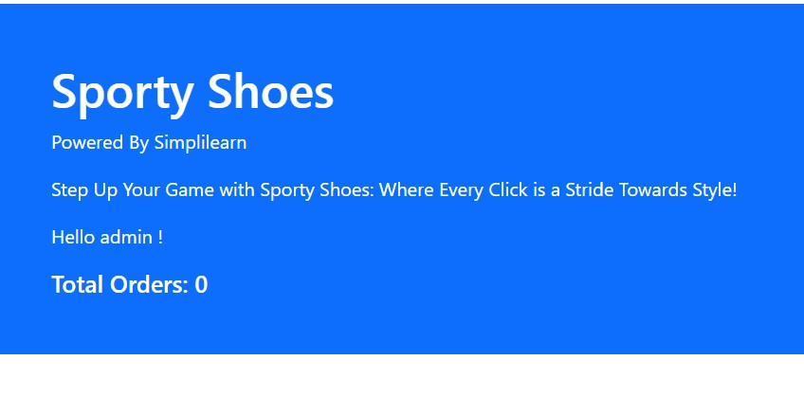

Next step add another class name as AddCart Page under same package

package com.sporty.shoes.SeleniumCucumberScripts;

import org.openqa.selenium.JavascriptExecutor;

import org.openqa.selenium.WebDriver;

import org.openqa.selenium.WebElement;

import org.openqa.selenium.support.FindBy;

import org.openqa.selenium.support.PageFactory;

public class AddtoCartPage {

@FindBy(xpath="//a[@id=\"shoe101\"]")

WebElement viewShoeBTN;

@FindBy(xpath = "//a[@id='cart101']")

WebElement addtocartBTN;

@FindBy(xpath="//div[@class='alert alert-success']/descendant::p[1]")

WebElement successText;

JavascriptExecutor executor;

public AddtoCartPage(WebDriver driver) {

PageFactory.initElements(driver, this);

executor = (JavascriptExecutor) driver;

}

public void add_product_to_cart() throws InterruptedException

{

executor.executeScript("arguments[0].click();", addtocartBTN);

}

public String validate_success_message()

{

String successtext = successText.getText();

return successtext;

}

}

**ScreenShot:**

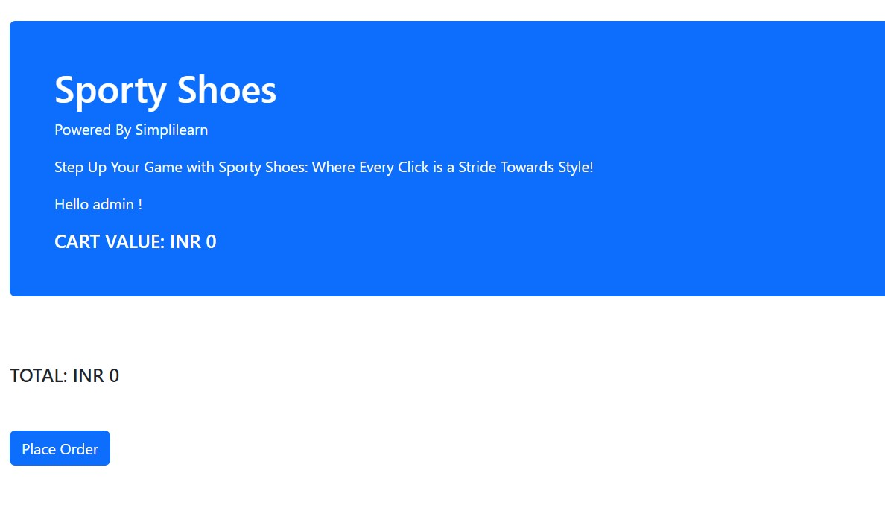

Next go to create another package name com.sportyshoe.Tests

Under class name as orderPageTests

package com.sportyshoe.test;

import org.testng.Assert;

import org.testng.annotations.BeforeTest;

import org.testng.annotations.Test;

import com.sporty.shoes.SeleniumCucumberScripts.HomePage;

import com.sporty.shoes.SeleniumCucumberScripts.LoginPage;

import com.sporty.shoes.SeleniumCucumberScripts.OrderPage;

import com.sporty.shoes.SeleniumCucumberScripts.RegisterPage;

import com.sporty.shoes.SeleniumCucumberScripts.TestBase;

public class OrderPageTest extends TestBase {

HomePage hp;

RegisterPage rp;

LoginPage lp;

OrderPage op;

@BeforeTest

public void start_browser()

{

OpenBrowser("Chrome");

hp = new HomePage(driver);

rp = new RegisterPage(driver);

lp = new LoginPage(driver);

op = new OrderPage(driver);

}

@Test(priority='1')

public void test_login()

{

lp.user_login();

}

@Test(priority='2')

public void test_click_orders()

{

op.click_orderPage();

}

@Test(priority='3')

public void test_getTitle_page()

{

String expected = "http://localhost:9010/orders";

String Actual = hp.getURL_page();

Assert.assertEquals(Actual, expected);

}

}

Next class AddCartPage under same package

package com.sportyshoe.test;

import org.testng.Assert;

import org.testng.annotations.BeforeTest;

import org.testng.annotations.Test;

import com.sporty.shoes.SeleniumCucumberScripts.AddtoCartPage;

import com.sporty.shoes.SeleniumCucumberScripts.HomePage;

import com.sporty.shoes.SeleniumCucumberScripts.LoginPage;

import com.sporty.shoes.SeleniumCucumberScripts.RegisterPage;

import com.sporty.shoes.SeleniumCucumberScripts.TestBase;

public class AddtoCartPageTest extends TestBase {

HomePage hp;

RegisterPage rp;

LoginPage lp;

AddtoCartPage ac;

@BeforeTest

public void start_browser()

{

OpenBrowser("Chrome");

hp = new HomePage(driver);

rp = new RegisterPage(driver);

lp = new LoginPage(driver);

ac = new AddtoCartPage(driver);

}

@Test(priority='1')

public void test_login()

{

lp.user_login();

}

@Test(priority='2')

public void test_add_product_to_cart() throws InterruptedException

{

ac.add_product_to_cart();

}

@Test(priority='3')

public void test_validate_success_message()

{

String expected = "Message:Shoe BlueWave Running Shoes Added Successfully to Cart";

String actualText= ac.validate_success_message();

Assert.assertEquals(actualText, expected);

}

}

Next go to another class name HomePageTests

package com.sportyshoe.test;

import org.testng.annotations.AfterTest;

import org.testng.annotations.BeforeTest;

import org.testng.annotations.Test;

import com.sporty.shoes.SeleniumCucumberScripts.HomePage;

import com.sporty.shoes.SeleniumCucumberScripts.TestBase;

import static org.testng.Assert.assertEquals;

import org.testng.Assert;

import org.testng.Assert.*;

public class HomePageTest extends TestBase {

HomePage hp;

@BeforeTest

public void start_browser()

{

OpenBrowser("Chrome");

hp = new HomePage(driver);

}

@Test(priority='1')

public void test_getTitle_page()

{

String expected = "http://localhost:9010/";

String Actual = hp.getURL_page();

Assert.assertEquals(Actual, expected);

}

@Test(priority='2')

public void Test_Validate_Text_On_Page()

{

String expected = "Powered By Simplilearn";

String actualText = hp.Validate_Text_On_Page();

Assert.assertEquals(actualText, expected);

}

@Test(priority='3')

public void test_click_register_link() throws InterruptedException

{

Thread.sleep(1500);

hp.click_register_link();

}

}

Next go to add another class LoginPage Test under same Package

package com.sportyshoe.test;

import org.testng.Assert;

import org.testng.annotations.BeforeTest;

import org.testng.annotations.Test;

import com.sporty.shoes.SeleniumCucumberScripts.HomePage;

import com.sporty.shoes.SeleniumCucumberScripts.LoginPage;

import com.sporty.shoes.SeleniumCucumberScripts.RegisterPage;

import com.sporty.shoes.SeleniumCucumberScripts.TestBase;

public class LoginPageTest extends TestBase {

HomePage hp;

RegisterPage rp;

LoginPage lp;

@BeforeTest

public void start_browser()

{

OpenBrowser("Chrome");

hp = new HomePage(driver);

rp = new RegisterPage(driver);

lp = new LoginPage(driver);

}

@Test(priority='1')

public void test_login()

{

lp.user_login();

}

@Test(priority='2')

public void test_getTitle_page()

{

String expected = "http://localhost:9010/login";

String Actual = hp.getURL_page();

Assert.assertEquals(Actual, expected);

}

@Test(priority='3')

public void Test_validate_registration_Text()

{

String expected = "Hello Prem Kumar R !";

String actualText = rp.validate_registration_Text();

Assert.assertEquals(actualText, expected);

}

@Test(priority='4')

public void test_click_cart()

{

lp.click_cart();

}

}

Next go to another class add registerPagetests

package com.sportyshoe.test;

import static org.testng.Assert.assertEquals;

import org.testng.Assert;

import org.testng.annotations.BeforeTest;

import org.testng.annotations.Test;

import com.sporty.shoes.SeleniumCucumberScripts.HomePage;

import com.sporty.shoes.SeleniumCucumberScripts.RegisterPage;

import com.sporty.shoes.SeleniumCucumberScripts.TestBase;

public class RegisterPageTest extends TestBase {

HomePage hp;

RegisterPage rp;

@BeforeTest

public void start_browser()

{

OpenBrowser("Chrome");

hp = new HomePage(driver);

rp = new RegisterPage(driver);

}

@Test(priority='1')

public void test_click_register_link() throws InterruptedException

{

Thread.sleep(1500);

hp.click_register_link();

}

@Test(priority='2')

public void test_getTitle_page()

{

String expected = "http://localhost:9010/register";

String Actual = hp.getURL_page();

Assert.assertEquals(Actual, expected);

}

@Test(priority='3')

public void Test_register_user()

{

rp.register_user();

}

@Test(priority='4')

public void Test_validate_registration_URL()

{

String expected = "http://localhost:9010/register-user";

String Actual = rp.validate_registration_URL();

assertEquals(Actual, expected);

}

@Test(priority='5')

public void Test_validate_registration_Text()

{

String expected = "Hello Prem Kumar R !";

String actualText = rp.validate_registration_Text();

Assert.assertEquals(actualText, expected);

}

}

5.Setup Cucumber in Java Project and write Feature Files using Gherkin to test the API endpoints mentioned in point 1 above.

First go to eclipse create a java project add feature file convert into step defintion file

Feature: first login to the spotyshoe. login page using local host:9010

Background:

Given I open the browser and enter URL

Then I capture the title of the Page

When I enter username and password

Then I click on login button

Scenario: User has to test if login on sportyshoe.login is successful or not

And I should see an Error message

Then I click on Click Here link

And I close the browser

Scenario:

Then I click on Create a sportyshoe. account

Then I capture the title of the Page

And I close the browser

Steps:

**package** com.sportyshoe.steps;

**import** org.openqa.selenium.WebDriver;

**import** org.openqa.selenium.WebElement;

**import** org.openqa.selenium.support.FindBy;

**import** org.openqa.selenium.support.PageFactory;

**public** **class** LoginPage {

@FindBy(xpath="//input[@id='email']")

WebElement loginEmail;

@FindBy(xpath="//input[@id='password']")

WebElement loginpassword;

@FindBy(xpath="//button[@type='submit']")

WebElement loginbtn;

@FindBy(linkText="Cart")

WebElement clickCart;

**public** LoginPage(WebDriver driver) {

PageFactory.*initElements*(driver, **this**);

}

**public** **void** user_login()

{

loginEmail.sendKeys("admin@gmail.com");

loginpassword.sendKeys("admin@123");

loginbtn.click();

}

**public** **void** click_cart()

{

clickCart.click();

}

}

ScreenShot:

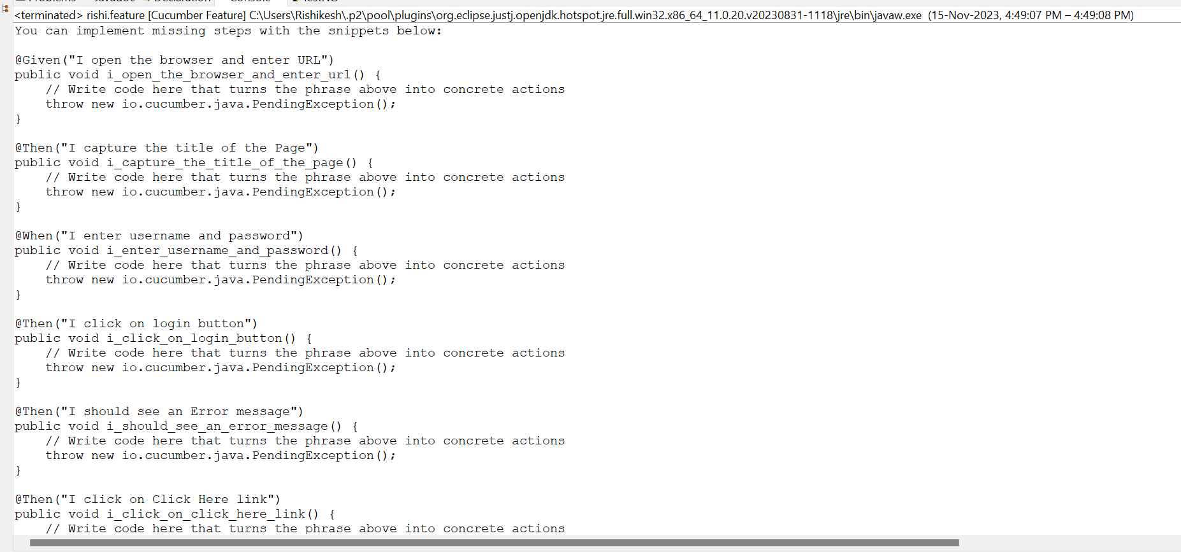

Gherkin feature file

